

**Evaluation of Interpersonal Synchronization between Individuals based on Video Recording**

Capstone Project Phase B

P. 24-1-R-17

InterSync Project Book

Dana Soudry 315015958

Semion Rodman 319636395

**Project Advisor**

**Dr. Anat Dahan**

2024

Contents

Abstract 2

**1.Introduction** 2

**2. Review and Process Description** 4

2.1. Development Process: 4

2.1.1 Client Interface 4

2.1.2 Main Supporting Modules 4

2.1.3 Algorithm Description 6

2.1.4 InterSync Outputs: 19

2.1.3 Smith-Waterman Adaptation for Synchrony Analysis - Explanation for an unorthodox choice: 25

2.2 Testing Process 31

2.3. Conclusions 34

2.4. Future work and improvements 35

**3. User Documentation** 37

3.1 User Documentation 37

Table of Contents: 37

1. Introduction 37

2. System Requirements 37

3. Installation 38

4. Application Interface Overview 39

5. Key Features 41

3.2 Maintenance guide 51

# Abstract

Our InterSync project aims to develop a one-size-fits-all system for measuring Interpersonal Synchrony (IS) using video recordings and computer vision techniques. Our code aims to detect body landmarks leveraging the capabilities provided by Google’s MediaPipe suite of ML tools and calculate movement vectors, later represented as a set of time data series. The movements are in turn analyzed using methods like Dynamic Time Warping (DTW) and Time-Lagged Cross-Correlation (TLCC), as well as Smith-Waterman local sequence alignment algorithm that were specifically adapted to the task.

Our goal was to create a tool designed to aid researchers in studying conditions such as Autistic Spectrum Disorder (ASD) and Attention Deficit Hyperactivity Disorder (ADHD), by providing detailed synchronization measurements and generating visual reports. The system offers significant improvements over traditional tools by tracking body part-specific movements and providing automated analysis.

# **1.Introduction**

Interpersonal Synchrony (IS) refers to the coordination of movements, behaviors, emotions, and / or physiological responses between individuals. It represents one of a few fundamental aspects of human social interaction, allowing people to connect and communicate on a deeper level. Interpersonal Synchrony is commonly observed in conversational dynamics, collaborative activities, and parent-child interactions, where people interacting tend to naturally synchronize their movements and emotions to achieve a sense of social harmony. Researchers have shown that when people engage in synchrony, it enhances mutual understanding and fosters rapport, cooperation, and empathy. This synchrony plays a vital role in human development, influencing early attachment, social bonding, and emotional regulation.

The importance of Interpersonal Synchrony extends beyond typical social interactions, for example in the study of developmental disorders such as Autistic Spectrum Disorder (ASD) and Attention Deficit Hyperactivity Disorder (ADHD). In individuals with ASD, studies have revealed a measurable reduction in IS, largely due to impairments in social cognition. People with ASD may struggle with social orienting, responding to social cues, and understanding the actions and emotions of others. These difficulties often lead to lower levels of synchrony during social interactions, which further promotes social isolation and increases communication challenges. For researchers and clinicians working with individuals with ASD, understanding the extent of these synchrony deficits is crucial for diagnosing and developing intervention strategies.

Similarly, ADHD is another disorder where decreased levels of IS are often observed. Individuals with ADHD can find it challenging to focus on social cues, engage in sustained interactions, or synchronize their movements with others. This lack of synchrony affects their ability to form and maintain social relationships, which may result in feelings of loneliness, social rejection, and poor social functioning over time. Importantly, these social difficulties do not disappear in adulthood - adults with ADHD often continue to struggle with social interaction, relationship-building, and maintaining emotional connections. As with ASD, studying Interpersonal Synchrony in the context of ADHD provides insights into the nature of social cognition impairments and can inform the development of therapeutic methods.

Researchers are currently using tools like the Motion Energy Analysis (MEA) system to quantify Interpersonal Synchrony from video recordings. MEA works by analyzing pixel-level changes between consecutive video frames and calculating, based on that, the amount of motion occurring within a predefined region of interest (ROI). However, the MEA system has several limitations that restrict its ability to provide detailed insights into interpersonal synchrony.

Firstly, MEA does not differentiate between specific body parts, instead it measures motion as a whole, which means that it cannot capture whether the movement of one specific body part is synchronized with another. This lack of focus on separate body parts makes it more difficult to analyze the coordination between two individuals. Secondly, MEA does not distinguish the directions of movement, making it impossible to determine whether two subjects are moving toward or away from each other. Additionally, MEA requires correctly positioned targets and a stable video environment, with no major changes in background or lighting, further limiting its practical use in real-world settings.

Considering these limitations, our project introduces a different system for measuring Interpersonal Synchronyusing advanced computer vision techniques. The project leverages MediaPipe’s PoseLandmarker, an open-source framework that detects body landmarks in real time, to track the movements of subjects captured in video recordings, which allows us to calculate and analyze the motion vectors of the targets. Our approach allows for the detection of multiple body landmarks simultaneously, such as the hands, shoulders, elbows, and knees, providing a detailed map of each subject's movement. By calculating vectors between these landmarks in time our project generates a more granular analysis of movement patterns, allowing for body part-specific synchronization measurements.

Unlike traditional tools like MEA, our project is capable of analyzing the direction and velocity of movements, providing a much clearer picture of how individuals move in relation to each other. We are hoping this could be useful in the context of ASD and ADHD research, where subtle differences in movement synchrony can possibly offer more insights into the cognition deficits associated with these disorders.

Our project employs similarity measuring algorithms such as Dynamic Time Warping (DTW), which accounts for time shifts in movement patterns, and Time-Lagged Cross-Correlation (TLCC), which measures how closely movements are aligned over time. These methods allow the system to assess synchrony even when movements occur at different speeds or with slight time delays, assuming the motions are expected to be synchronized.

Another powerful and new feature of our project is its use of the adapted Smith-Waterman algorithm, which is typically applied to sequence alignment in bioinformatics but has been adapted here for localized movement alignment. This enables our project to identify short bursts of synchronized movement between subjects, offering a more detailed analysis of intermittent synchrony.

Additionally, our project performs basic motion synchrony analysis to evaluate how often similar motion bursts happen over time, providing both broad and detailed insights into the synchronization process.

The primary goal of this project is to assist researchers in analyzing Interpersonal Synchrony more effectively. By automating the analysis process, our project reduces the time and effort required for manual observation and provides detailed reports in various formats, including PDF, Excel and CSV. These reports contain visual graphs (for PDF) and data tables that illustrate synchrony patterns, allowing users to quickly identify movement coordination between subjects, if one is to be found.

# **2. Review and Process Description**

## 2.1. Development Process:

### 2.1.1 Client Interface

The design of the client interface for the InterSync project was created with a set goal of making the application whose expected target audience will be researchers and other people working in the fields of behavioral sciences, psychology, and developmental disorders. Since many users may not have technical expertise in programming or computer vision, the system includes a Graphical User Interface (GUI), carefully designed through a number of iterations to be as accessible and intuitive as possible.

The GUI is built using PyQt and enables users to interact with the system through simple actions – represented by visual elements, such as uploading video files, configuring analysis settings, and generating reports. During the analysis stage users can select the body parts that are going to be analysed directly through the interface. The interface also includes options for selecting specific analysis methods available – Simple synchrony matching, Dynamic Time Warping, Time-Lagged Cross-Correlation, and adapted Smith-Waterman, with adjustable parameters for fine-tuning the analysis

### 2.1.2 Main Supporting Modules

1. MediaPipe: open-source suite of libraries and tools is being used in our project to detect body landmarks, such as shoulders, elbows, and hands in the frames extracted from the video. These landmarks, represented by their coordinates in the image, in 3 axis – x, y, and z (for relative depth) are later used to calculate vectors, which in turn represent how body parts move over time

2. OpenCV: library for handling video input used in our project for video manipulation, frame extraction, and parts of frame transformations (such as applying light blurring for more accurate comparison) required for video analysis. OpenCV handles the loading, reading, processing and saving of video files, and also handles extracting frames for synchrony analysis

3. NumPy: used throughout the project for vector and matrix operations, such as calculating movement vectors, normalizing data, and performing efficient numerical computations. It helps to simplify complex mathematical functions and vector operations needed for tracking body movements

4. Pandas: in our project parts of the data regarding movement vectors are being stored and processed in DataFrames - data structures constructed with rows and columns, similar to a database or Excel spreadsheet. They are being used for data manipulation and data export

5.PyQt6: used for building the graphical user interface (GUI) that enables users to interact with the system while streamlining the user experience.

6. PeakUtils: used for detecting peaks in the plotted video data, identifying keyframes where significant motion occurs

7.FastDTW: Python implementation of the FastDTW algorithm, used for the DTW analysis, while providing near-optimal alignments with an O(N) time and memory complexity, in contrast to the O(N^2) requirement for the standard DTW [https://cs.fit.edu/~pkc/papers/tdm04.pdf]

7. ReportLab: used to generate PDF reports

### 2.1.3 Algorithm Description

The process is divided into 2 parts - each being initiated by the user

First part being the video analysis process - with the final goal of producing 2 datasets that represent motion data for the analysis targets

The stages of the process are as follows:

#### **Frame Selection:**

##### Keyframe Detection

The video being analysed is first processed frame-by-frame using OpenCV for video processing and frame extraction, then, the extracted frames are being compared to each other - to detect major changes in the pixel values that are indicative of major changes in the image itself - under the assumption this change might represent a start or an end of a motion - thus defining a ‘Keyframe’ for at least one of the detection targets.

The values are plotted and a user-defined threshold value is applied using a PeakUtils library. The frames that correspond to the threshold-crossing peaks are being returned as a ‘Keyframe array’ used for all following analysis

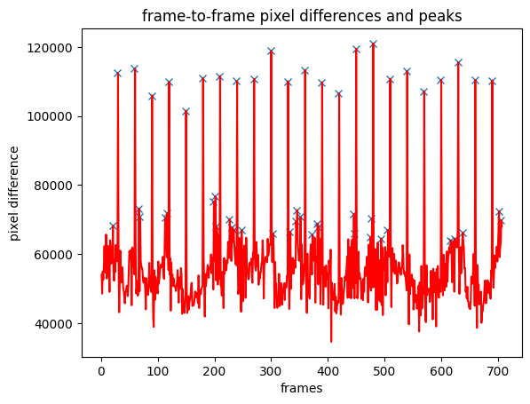

*Figure 1: Example of the data plotted to show the pixel value difference between frames. Marked by ‘x’ mark are the peaks corresponding to the frames being selected for future processing. The Threshold value used is 0.35*

##### Frame Selection with skips:

Additional option introduced in our system for building a set of frames to base the analysis on - “frame selection with skips” intended to cover cases where the dynamics of the scene makes the keyframe detection process unreliable for multiple reasons, such as dynamic background, consistent movements that do not translate into discrete segments that can be detected, etc.

When using this option the user provides an integer value that is being used as a counter for skipping frames, to ensure the analysis is done on a manageable amount of sufficiently different data.

For example, for the value provided ‘10’ - each 10th frame is selected for the analysis, disregarding the frame contents and suitability

#### **Video Analysis**

##### Image Landmark Detection using MediaPipe:

At this stage the frame data gathered during the first stage is being run through the MediaPipe Landmark Detection task, to holistically detect the landmarks known to the system, based on the model provided.   
The task uses a convolutional neural network similar to MobileNetV2 and is optimized for on-device, real-time applications. A variant of the BlazePose model uses GHUM (Heavy), a 3D human shape modeling pipeline, to estimate the full 3D body pose of an individual in images [https://ai.google.dev/edge/mediapipe/solutions/vision/pose_landmarker]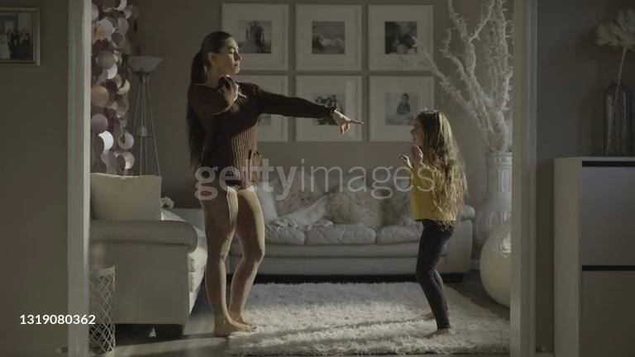

*Figure 2: Original frame extracted from a video*

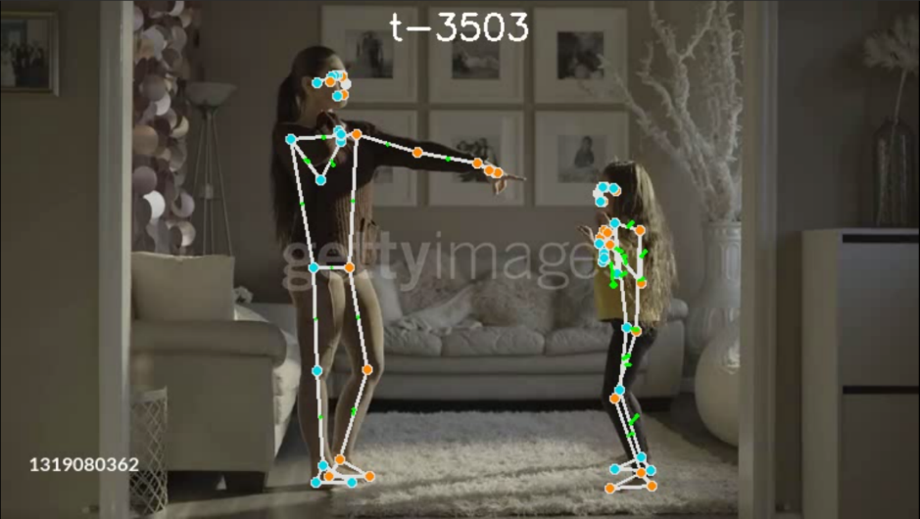

*Figure 3: Frame with detection results of both targets overlaid on it*

##### Data-Target Classification:

For each frame analysed the system records the data regarding the detected location of each of the 33 detection points as a dataset, for both targets detected (or only one target, if the detection fails for a number of reasons listed later)  
Now we are tasked with locating which target the data is related to.

For the initial stage we randomly mark one detection target to be ‘Target1’ and second to be ‘Target2’

For each next iteration of the detection process we calculate the ‘Target Center’ coordinates as follows:

With $LSx,LSy,LSz$ coordinates of the Left Shoulder landmark in the dataset detected by the MediaPipe on the frame given

$RSx​,RSy​,RSz​$– coordinates of the Right Shoulder landmark

We calculate the ‘center’ $Cx,Cy,Cz$ of the given target for the frame as follows:

$C_{x}=\frac{{LS}_{x}+{RS}_{x}}{2}$, $C_{y}=\frac{{LS}_{y}+{RS}_{y}}{2}$, $C_{z}=\frac{{LS}_{z}+{RS}_{z}}{2}$

Next, we compare the Euclidean distance between the previously detected center and a new, calculated center, and assign the datasets to the detection Targets accordingly

##### Creating ‘Vector-Frames’

For our project we are using data objects representing the dataset of vectors for each motion – where each such object includes all the relevant data for each motion between ‘start time’ and ‘end time’.

Whenever two consecutive Landmark points data sets are assigned to the Target – the system calculates a ‘VectorFrame’ which includes all the original detection data, for future re-use

##### Calculating Limb Movement Vectors based on Landmarks:

Next, we are calculating the motion of the limbs using landmarks that represent the start and the end point of each limb.

For a pair of landmarks $\left(lm1,lm2\right)$ with coordinates $\left(x_{1},y_{1},z_{1}\right)$ and $\left(x_{2},y_{2},z_{2}\right)$ the limb midpoint M is calculated as:

$$M=\left(\frac{x_{1}+x_{2}}{2},\frac{y_{1}+y_{2}}{2},\frac{z_{1}+z_{2}}{2}\right)$$

Representing the average of the coordinates of the two landmarks, giving the central point of the limb

Once the midpoints for both the start and end frames are computed, the limb movement vectors are determined by calculating the difference between the midpoints of the end frame and the start frame.

For a limb midpoint in the start frame $M_{start}$ ​ and in the end frame $M_{end}$ the movement vector $V_{limb}$ ​ is given by:

$V_{limb}= M_{start}- M_{end}$

​ ​

This is gives us the motion of the limb from the start to the end of the frame, while still operating in the original image coordinates

##### New Basis Vector Calculations

As we are interested in the motion of the detection Target itself, we are changing our coordinate system to match our needs for the future analysis.  
These new basis vectors are fundamental for transforming the coordinate system from image-based coordinates to a target-based coordinates. In our project this process involves calculating three orthogonal vectors that define the new coordinate axis: X, Y, and Z. This is done as follows:

We start with a ‘midpoint calculations’:

For $S_{left}$– Shoulder Left, $S_{right}$– Shoulder Right, $H_{left}$– Hip Left, $H_{right}$– Hip Right:

Shoulder Midpoint - $S_{mid}=\frac{S_{right}+S_{left}}{2}$

Hip Midpoint - $H_{mid}=\frac{H_{right}+H_{left}}{2}$

Then we calculate the new axis themselves:

The X-axis is defined as the vector from the hip midpoint to the shoulder midpoint:

$$x'=\frac{S_{mid}-{ H}_{mid}}{‖S_{mid}-{ H}_{mid}‖}$$

The Y-axis is defined as the vector from the left shoulder to the right shoulder:

$$y'=\frac{S_{right}- S_{left}}{‖S_{right}- S_{left}‖}$$

The Z-axis is calculated by taking the cross product of the X’ and Y’ axes. The cross product yields a vector that is orthogonal to both X’ and Y’:

$$z'=\frac{x'× y'}{‖x'× y'‖}$$

This process helps us to define a new coordinate system aligned with the anatomy of the target for future analysis of movement data.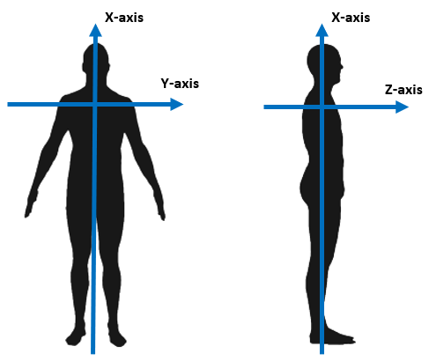

*Figure 4: representation of new Target-relative coordinates system*

##### Limb Motion Vector transformation to a Target-relative coordinates system

Lastly, based on all previous calculations – a vector transformation is done using dot products of original movement vectors with each of the new basis vectors to get new coordinates

At this point we are able to compile a dataset of transformed motion vectors that describe the motion of the Target based on the analysis of the video provided.

This data set can be exported as-is per each trarget, and is being used for further analysis by the user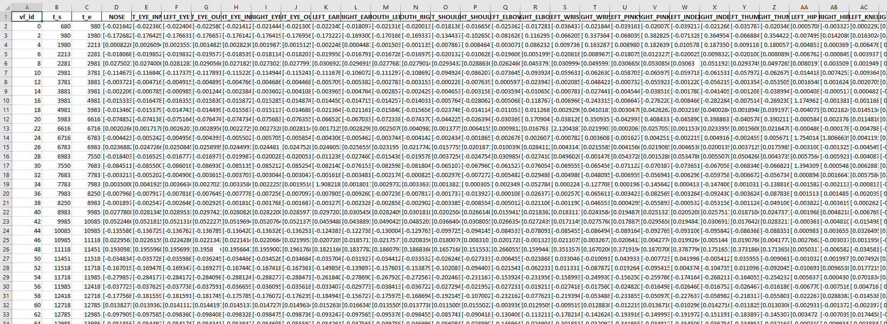

*Figure 5: example of the Excel export of the data set for one of the analysis targets*

#### **Synchrony Analysis**

At this point we are presenting the user with an array of tools to perform Synchrony analysis. As we found during the development stages – there is no unified set of analysis parameters that perfectly suits all the videos we were testing, and as such we decided to let the user configure the Synchrony Analysis runs, and select the tools and parameters that produce the best result

##### 3.1. Basic Similarity Analysis

Our basic similarity analysis method compares individual segments of movement data between two subjects to identify timeframes where their movements are most similar. The process uses either Cosine or Euclidean distance to measure the similarity between movement segments from two subjects.

The formula for determining similarity using Euclidean distance is based on the calculated distance between the two vectors and . If the distance is less than the threshold, the vectors are considered similar. The distance is calculated as:



And the later comparison performed is if the vectors are considered similar for the purpose of the analysis

For Cosine similarity, the comparison is based on the similarity between the angles of the two vectors. The cosine similarity score is computed as:



And the distance is defined as



Later comparison performed is if the vectors are considered similar for the purpose of the analysis

This analysis method consists of comparing each movement segment of the first subject with all segments of the second subject, and if the similarity is within a defined threshold, it is considered a match. The analysis produces a list of timeframes where the two subjects' movements were highly similar above the threshold defined

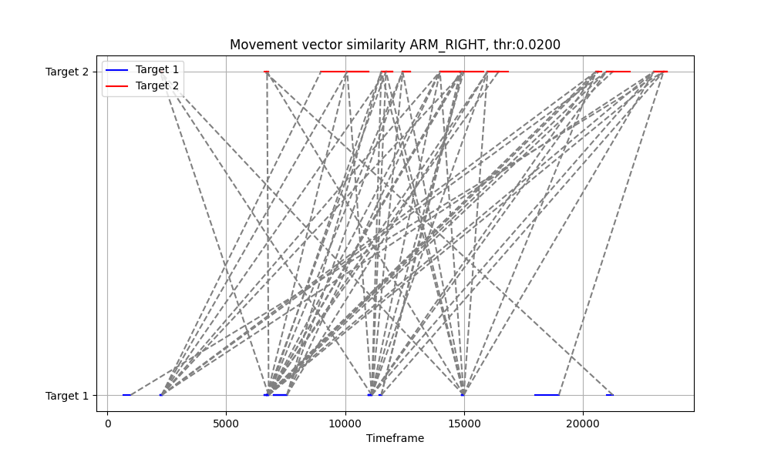

*Figure 5: example of the Basic Similarity Analysis plot done for right arm, Euclidean distance with threshold of 0.02*

##### 3.2. Dynamic Time Warping (DTW)

In our project we are using DTW to measure the similarity between two sequences of movement vectors by aligning them in a way that minimizes the cumulative distance between corresponding movement segments.

We found this method is useful (as expected) for comparing sequences of movement that may be similar in shape, whenever the subjects are explicitly trying to copy each other, but are not perfectly synchronized in time

On the downside – whenever the subjects are moving freely in space without a pre-defined goal of coordination – this analysis method tends to produce unreliable results due to the nature of random movement

For two sequences of movement marked A, B the DTW calculates the distance as:



The algorithm in its classic form computes a cumulative distance matrix by recursively calculating the cost of aligning each point in one sequence with a point in the other sequence. The goal is to find the optimal warping path through this matrix that minimizes the overall alignment cost between the sequences

In our project we opted to use a modification to DTW – FastDTW algorithm.

The FastDTW implementation, used in the project reduces the computational complexity of traditional DTW, by adding restrictions to the analysis process, making it suitable for large datasets and real-time analysis. Additionally, it is easier on the computational resources of the PC with was also one of our considerations, as the project is designed to work on laptops as well.

The algorithm approximates the DTW distance with linear time and memory complexity, allowing it to handle longer sequences efficiently. In this method of analysis, the distance between two sequences is computed, and as with the **Basic Similarity Analysis**, we provide the user with an option to either calculate the Euclidean or Cosine distance during the run.

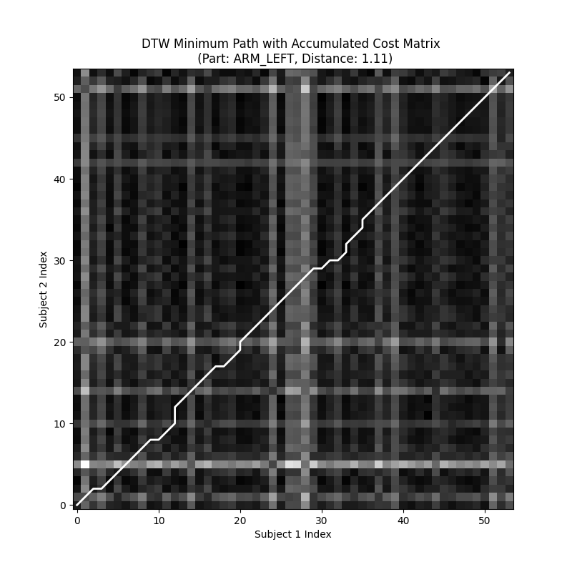

*Figure 6: an example plot of the warping path through cumulative distance matrix, for left arm. The optimal distance calculated is 1.11*

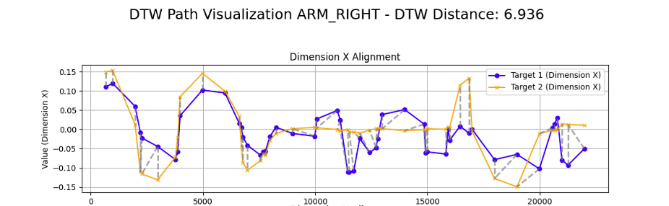

*Figure 7: Example of DTW alignment visualization for right arm, separate for X axis, DTW distance of 6.93*

##### 3.3 Time-Lagged Cross-Correlation

We added this method to our project to give the user an ability to measure the similarity between two time-series sequences of movement vectors by calculating how one sequence is correlated with a time-shifted version of the other.

This analysis technique helps to determine whether one subject’s movements lead or follow the other’s and to what extent they are synchronized across different time lags.

The TLCC method calculates cross-correlation between two sequences at a lag as:  


This calculation results in a correlation score for each time lag, representing how well the two sequences align when one is shifted relative to the other.

The correlation is calculated for a range of lags to try and capture any lead-lag relationships between the sequences.

In the project, we compute these correlation scores for each lag and try to find the lag with the highest correlation, which should be indicating the optimal time shift for maximum synchrony between the two movement sequences.

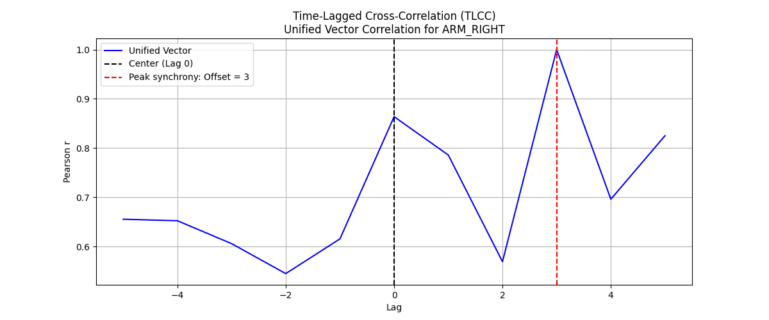

*Figure 8: Example result plot of TLCC analysis with peak synchrony calculated at a lag of 3 movements*

##### 3.4 Smith-Waterman algorithm

While searching for a more suitable ways of alignment calculation we found information about Smith-Waterman algorithm - a dynamic programming algorithm traditionally used in bioinformatics for local sequence alignment of DNA sequences.

The algorithm builds a scoring matrix, not unlike DTW, where each cell contains the score for aligning the corresponding elements of the two sequences, incorporating penalties for gaps and mismatches. The scoring formula for the matrix is as follows:



Where:

* is the score at position and  in the scoring matrix.
* The match/mismatch score is positive for similar movements and negative for dissimilar ones.
* The gap penalty is subtracted when aligning one vector with a gap in the other sequence

The algorithm traces back from the highest value in the matrix to find the optimal local alignment

Adaptation in the Project:

In our project, Smith-Waterman algorithm was rewritten and adapted to compare movement sequences between two movement data sets. Instead of biological sequences, the algorithm aligns vectors representing body movements across video frames. The scoring matrix is built using a movement similarity score between vectors, based on Euclidean or Cosine distance (as described in the **Basic Similarity Analysis** section).

Gaps are penalized to account for periods where one subject moves while the other remains stationary.

The parameters for the gap / score / mismatch are available for modification by the user before the analysis start – to account for different videos, and different goals of the analysis – i.e. to find the most matching single movements, or longest similar stretches of movement.

Our goal is to try and identify locally synchronized movement patterns, where the movements of both subjects are aligned for short time intervals, while the rest of the movement is non-matching. For example – one movement being copied from the whole sequence. We compute this alignment by finding regions where movements are most similar, with the result being a local alignment score and the corresponding sequence of aligned vectors.

This allows us to highlight specific moments of synchrony, even if the entire movement sequence is not synchronized

*Figure 9: Example of Smith-Waterman analysis – with green lines representing the alignment of movements across two targets.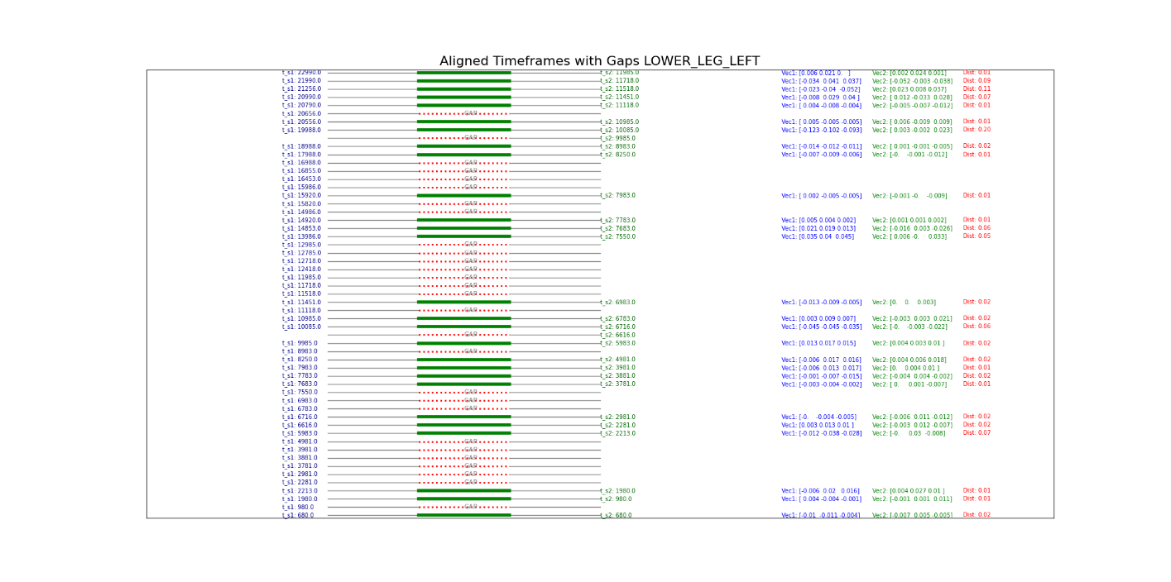*

#### **Algorithms Summary**

|  |  |  |  |  |  |
| --- | --- | --- | --- | --- | --- |
| Method | Description | Best Use Cases | Comparison Basis | Upsides | Downsides |
| Dynamic Time Warping (DTW) | Measures the similarity between two sequences by aligning them, allowing for shifts in time and speed. | Long, continuous sequences with varying timings; good for comparing overall movement patterns. | Movement vectors over time | Handles time shifts and sequences with different lengths.  fits for non-linear comparisons. | Computationally expensive for long sequences; may stretch sequences unrealistically; |
| Smith-Waterman Algorithm | Adapted from bioinformatics, it performs local alignment between two sequences, penalizing gaps and mismatches. | Detecting local synchrony in segments; useful when the focus is on specific, isolated moments of synchrony. | Localized movement sequences | Good for finding localized patterns and segments of synchrony; accounts for gaps and mismatches. | Resource-intensive; less suited for global synchrony analysis; complexity increases with sequence length. |
| Time-Lagged Cross-Correlation (TLCC) | Measures correlation between two sequences over a range of time lags to determine lead-lag relationships. | Analyzing sequences with a time lag; good for lead-follow dynamics in interactions. | Correlation of movement vectors with time lags | Effective for identifying lead-lag relationships; handles real-time shifts in movement synchrony. | Computationally expensive for large lag ranges; may be less effective if sequences are highly non-linear. |
| Simple Matching Synchrony Analysis | Compares movement vectors directly, determining similarity based on a threshold for distance (Euclidean or Cosine). | Simple or short sequences with minimal time variation; good for quick comparisons. | Direct comparison of movement vectors | Fast and computationally efficient; easy to interpret; ideal for quick, straightforward analysis. | Does not handle time shifts or varying sequence lengths well; not suitable for complex synchrony patterns. |

### 2.1.4 InterSync Outputs:

Our project generates comprehensive outputs that enable detailed examination of synchronization between two subjects.

The system provides an overall run report and in addition provides user with a functionality of exporting data summaries and visualizations that can be used for better understanding of the degree and dynamics of synchrony by providing clear, interpretable results

#### **Summary Reports**

The system provides a general overall run report in a PDF format, which contains the results from various synchronization analyses—Similarity Analysis, Dynamic Time Warping (DTW), Smith-Waterman, and Time-Lagged Cross-Correlation (TLCC). Each section of the report is structured to provide detailed fields that summarize the results of these analyses, including the thresholds applied, key similarity metrics, and performance of the algorithms in aligning or correlating the subjects’ movements.

Additionally, we give an option to export the raw movement data and the analysis results as excel or csv files for future use

#### **Similarity Analysis:**

**Threshold:** defines the maximum allowable distance between movement vectors for them to be considered similar, with smaller thresholds indicating stricter similarity requirements

**Metric:** Euclidean or Cosine metrics, which determine how similarity is calculated—spatial distance for Euclidean, and angular similarity for Cosine.

**Normalized:** this parameter indicates whether the movement vectors were adjusted to ensure they are on the same scale before comparison, which is important for dealing with movements of different magnitudes

**Number of Similar Segments:** this parameter reflects how many similar movements were found between the two subjects for the given body part, offering insight into the extent of synchrony

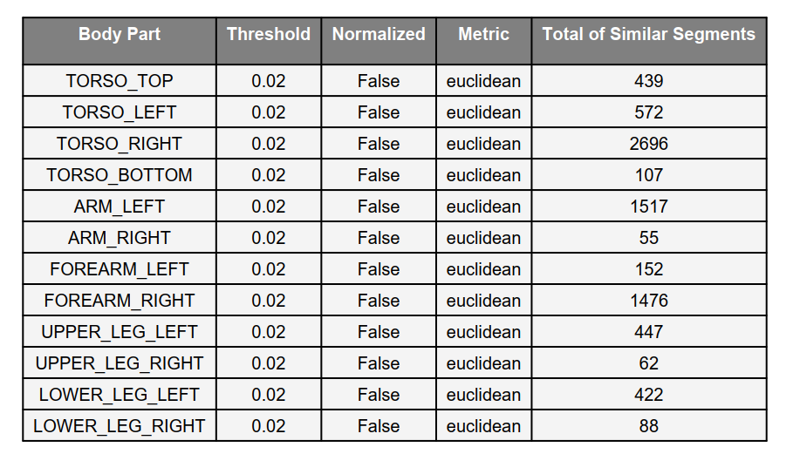

*Figure 10: Basic Similarity Analysis summary export – the formatting as per PDF report, the data is available as a data set export as well*

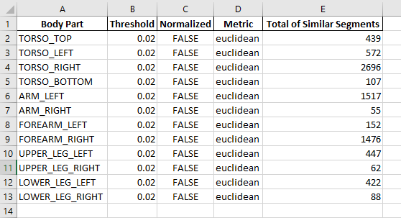

*Figure 11: Excel data export example*

#### **Dynamic Time Warping (DTW)**

The DTW results focus on the temporal alignment of movement vectors between the two subjects, even when the movements are not perfectly synchronized in time. The output includes the following important fields:

* **Path Length**: The length of the optimal alignment path between the two sequences. This value reflects how much warping or stretching was needed to align the movements of the subjects. A shorter path length indicates less temporal distortion, meaning the movements were already closely aligned in time
* **Accumulated Cost Matrix values**: reflects the cumulative cost of aligning each point in one sequence with the corresponding point in the other sequence. The accumulated cost at each step represents the difficulty of aligning the movements at that time step, with lower values indicating easier alignment
* **Min, Max, and Mean Cost** values provide insight into the difficulty of aligning the sequences at specific moments (minimum and maximum) and overall (mean). These metrics are important for understanding the quality of the alignment
* **Warping Distance**: This is the total distance required to warp one sequence to align with the other, which represents the overall difficulty in aligning the two subjects' movements. Lower warping distance indicates better synchrony, while higher values suggest significant differences in timing or movement patterns
* **Smooth** and **Smooth Window** parameters indicate whether smoothing was applied to reduce noise, and the size of the window used for this purpose, helping refine the analysis by eliminating irrelevant fluctuations

*Figure 12: Examples of the DTW data sets produced.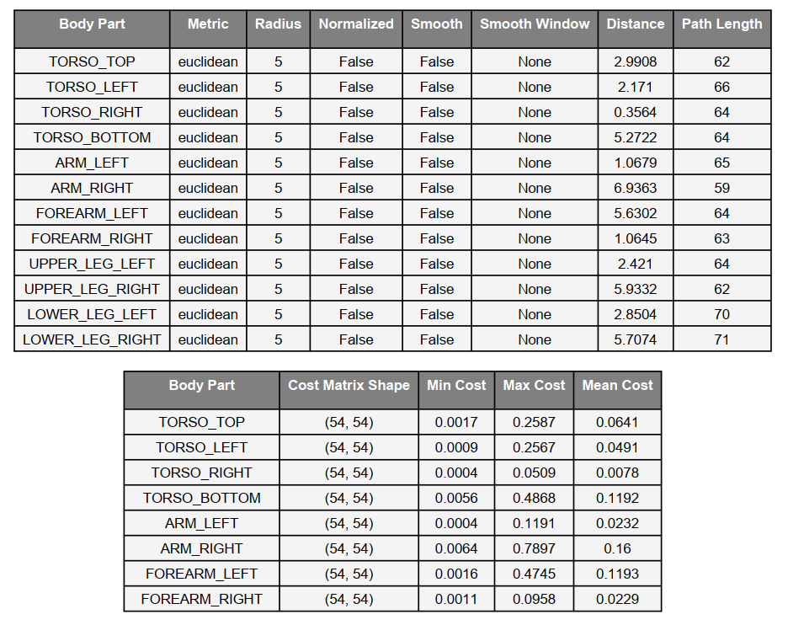*

#### **Smith-Waterman Analysis**

* **Match Score**: User-set parameter for the analysis run. This value reflects the score assigned when two vectors are considered a match. A higher match score increases the importance of finding similar vectors in the alignment, influencing the overall alignment score produced by the analysis run
* **Mismatch Penalty:** User-set parameter for the penalty that is being applied when two vectors do not align. A higher penalty discourages mismatched alignments, ensuring that only significant matches are prioritized
* **Gap Penalty:** User-set parameter for penalty for introducing gaps (i.e. skipping data points where one subject moves, and the other does not). Encourages the algorithm to minimize gaps, leading to a more contiguous alignment between movements.
* **Alignment Score:** Total score representing the overall quality of the alignment. The higher the alignment score, the better the alignment between the sequences. This is the value that should be used to compare different alignments
* **Aligned Segments:** Number of segments that were successfully aligned, excluding gaps. Provides insight into how much of the movement data from both subjects could be aligned, indicating the extent of synchronization

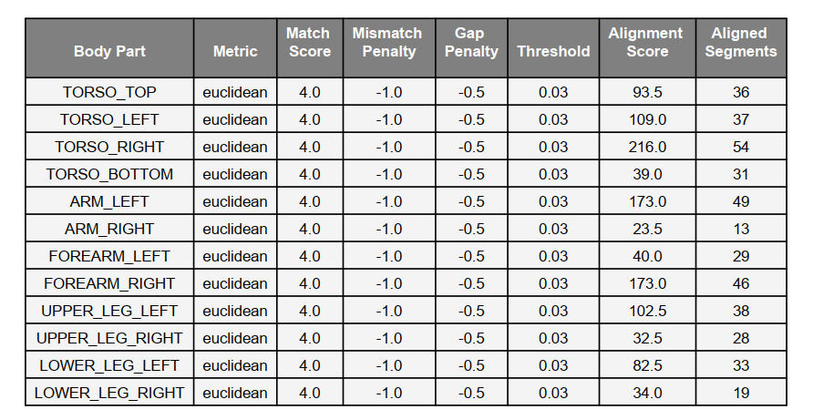

*Figure 13: Examples of the Smith-Waterman data sets produced.*

#### **Time-Lagged Cross-Correlation (TLCC):**

* **Max Lag**: The maximum lag (time shift) considered during the analysis. Defines the range of time shifts tested during the analysis to find the optimal alignment between the two subjects’ movements
* **Separate Dimensions**: indicating whether TLCC was computed for each movement dimension (X, Y, Z) separately. Allows for more detailed analysis of how movements align in specific spatial dimensions
* **Peak Correlation**: highest correlation value observed during the analysis. A Value between -1 and 1. Indicates the best possible alignment between the two sequences, with values close to 1 representing strong synchrony
* **Peak Lag**: time shift at which the peak correlation was observed. Shows whether one subject led or followed the other in their movement
* **Average Correlation / Correlation Standard Deviation**: mean and standard deviation of the correlation values across all time lags - reflects the overall strength and consistency of the synchrony between the two subjects
* **Peak Correlation X, Y, Z** / **Peak Lag X, Y, Z**: Peak correlation values and their corresponding lags for each movement dimension (X, Y, Z). These fields break down the analysis by dimension, providing insights into how movements align in given axis

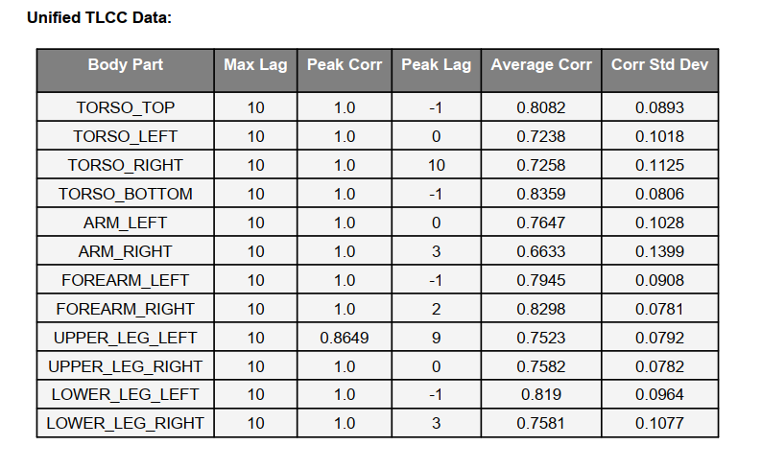

Figure 14: Examples of the TLCC data sets produced – the data represents summary of the unified analysis, where the TLCC analysis is being produced based on the distances of the vectors in 3 dimensions – axis x,y,z

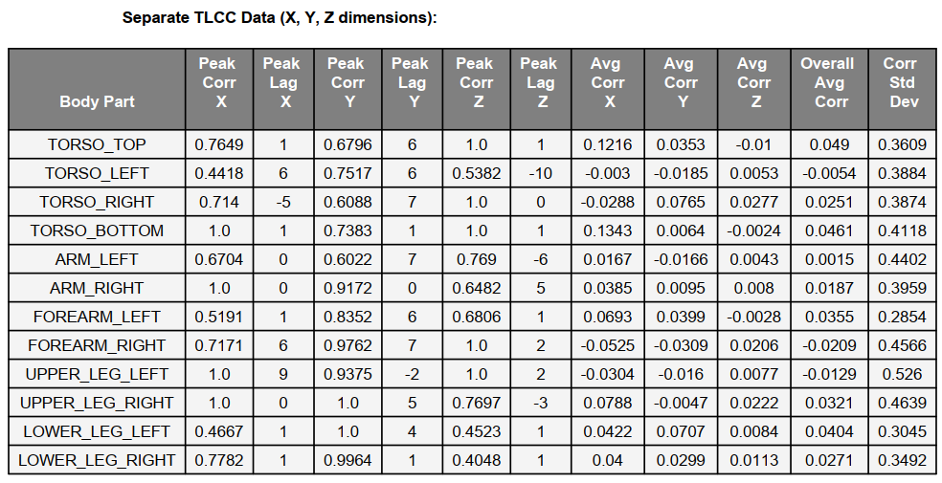

Figure 15: Examples of the TLCC data sets produced – this data represents summary of the separate analysis, where the TLCC analysis is being produced based on the distances of the vectors in separate dimensions

### Smith-Waterman Adaptation for Synchrony Analysis - Explanation for an unorthodox choice:

We encountered information about this algorithm while searching for the more optimized ways to analyse interpersonal synchrony, and decided to give it a try. As far as our search goes we seem to be the first ones to try and adapt this algorithm specifically to interpersonal synchrony.

The Smith-Waterman algorithm, initially developed for local sequence alignment in bioinformatics, has been adapted in this project to compare movement sequences between subjects. Traditionally, this algorithm is used to find optimal local alignments between biological sequences (e.g., DNA or proteins) by generating a scoring matrix and finding the highest scoring alignment path. Its ability to identify locally similar regions makes it useful for detecting brief but significant periods of synchrony in movement sequences, even when the overall movement patterns differ.

There is a small number of research articles we found while searching for Smith-Waterman being used as part of a motion analysis process, namely, D. E. Riedel, S. Venkatesh and W. Liu, "A Smith-Waterman Local Alignment Approach for Spatial Activity Recognition," (2006 IEEE International Conference on Video and Signal Based Surveillance, Sydney, NSW, Australia, 2006, pp. 54-54, doi: 10.1109/AVSS.2006.13), and Z. Li, F. Wu and M. C. Crofoot, "Mining Following Relationships in Movement Data," (2013 IEEE 13th International Conference on Data Mining, Dallas, TX, USA, 2013, pp. 458-467, doi: 10.1109/ICDM.2013.98). But neither of them is about strictly comparing extracted motion vectors of human subjects the way we attempt it.

#### Original algorithm

The original Smith-Waterman algorithm constructs a scoring matrix that measures similarity between two sequences. Each cell in the matrix holds a score based on matches, mismatches, and gaps. The algorithm applies a traceback procedure to identify the best local alignment by following the highest scoring path. This method focuses on identifying regions of high similarity while ignoring dissimilar or unrelated parts of the sequences.

#### Adaptation for movement synchrony in our project:

In our project, the Smith-Waterman algorithm has been adapted to handle time-series movement data derived from body landmarks in videos. Instead of comparing biological sequences, the algorithm compares vectors representing the movements of different body parts across video frames. The similarity between these vectors is calculated using either Euclidean distance or Cosine similarity, which determines whether two movements are sufficiently similar based on a predefined threshold.

The key parameters used in the algorithm adaptation are:

* Match Score: reward given when two movements are considered similar.
* Mismatch Penalty: penalty applied when movements are dissimilar.
* Gap Penalty: penalty used when one subject presents a motion vector while the other remains stationary, introducing a "gap" in the movement sequence.
* Threshold: value that let’s the algorithm decide if the movements are similar enough to be rewarded with the ‘Match Score’ - allows us to fine-tune the algorithm run

This scoring process results in a matrix where the optimal alignment path is traced back, identifying segments of synchronized movement between subjects. The use of Euclidean and Cosine metrics allows users to select for flexible comparison of both the magnitude and direction of movements.

#### Value of the approach

Despite being an unconventional choice for movement analysis, the Smith-Waterman algorithm offers unique value in detecting short, localized periods of synchrony. Unlike global alignment techniques like Dynamic Time Warping (DTW), which focus on aligning entire sequences, Smith-Waterman excels in identifying isolated segments where movements are synchronized, even if the overall movement patterns differ significantly.

For example, in scenarios where subjects mirror each other's movements only briefly, Smith-Waterman can detect these localized synchrony patterns without being influenced by the surrounding unsynchronized movements. This is particularly useful for analyzing human interactions where synchrony occurs intermittently, such as in parent-child or therapeutic settings, where brief moments of synchrony may hold significant meaning.

#### Technical details:

* Algorithm allows for flexibility in the similarity metric used, with options for Euclidean distance and Cosine similarity.
* Thresholds for determining similarity can be fine-tuned, ensuring that the algorithm detects meaningful synchrony rather than noise.
* Taceback process ensures that gaps (periods where one subject is stationary) and mismatches are handled appropriately, either by aligning the gap or penalizing the lack of movement.
* Visualization component provides graphical feedback on aligned sequences, displaying matching segments, gaps, and the corresponding movement vectors.

### Architecture:

As an overview of our process following flow chart describes the general algorithm:

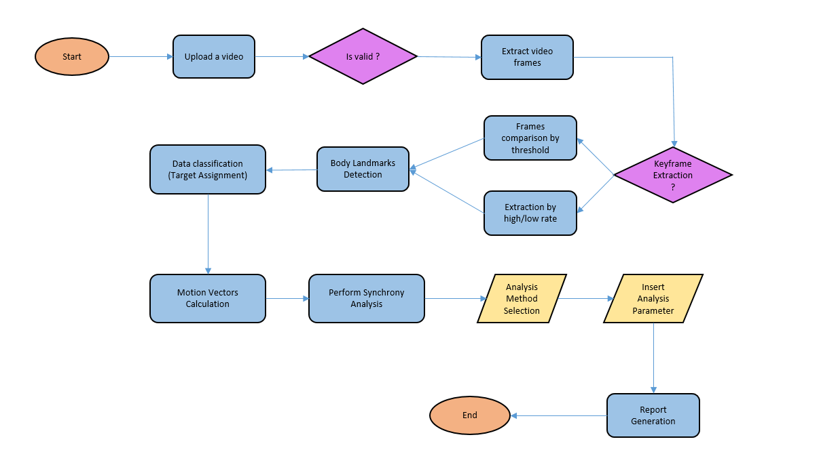

Our project is built as a multi-component application that processes video input, extracts movement data, transforms it and then allows the user to perform a synchrony analysis using various algorithms.

The system is divided into several modules, each responsible for a specific function, from video handling to analysis and reporting. These components communicate in a pipeline structure to ensure seamless data flow and efficient processing.

Using the fact that the codebase is written in Python programming language we sub-divided our code into packages: **Frames**, **Data**, **Detector**, **Analysis**, and **Reports,** with each package corresponding to a module, and each responsible for its major part of the process. Additionally we have the GUI created using PyQt6 that wraps it all together.

Frames package:

* Video handling: this package, making extensive use of OpenCV, manages video loading and additionally extraction and manipulation of individual frames from the uploaded video file.
* Keyframe detection: utilizing PeakUtils we identify keyframes—frames where significant movement occurs, if this is the option chosen by user

Detector package:

* Body landmark detection: this part of our program contains code that detects and extracts key body landmarks from the frames, using MediaPipe. It provides (x, y, z) coordinates for body parts like hands, shoulders, and elbows for the future calculations
* Target detection: this package also includes the code responsible for recognizing and tracking the subjects in the video, ensuring that movements are accurately assigned to each subject.

Data package:

* Vector frame calculation: this package contains the code that receives body landmarks identified by the system and calculates movement vectors between consecutive frames. These vectors represent the movement dynamics of various body parts.
* Storage and manipulation: Pandas and Numpy libraries are used extensively in this module to store movement data as structured DataFrames, and for vector calculations including coordinate transformations

Analysis package:

* Analysis algorithms: this package includes the code used for the analysis of the gathered data, using various analysis algorithms.

Reports package:

* Report generation: code that compiles the results from the Analysis package into structured output format and creates PDF reports. This part summarizes key metrics such as similarity scores, DTW distances, and correlation coefficients using ReportLab library

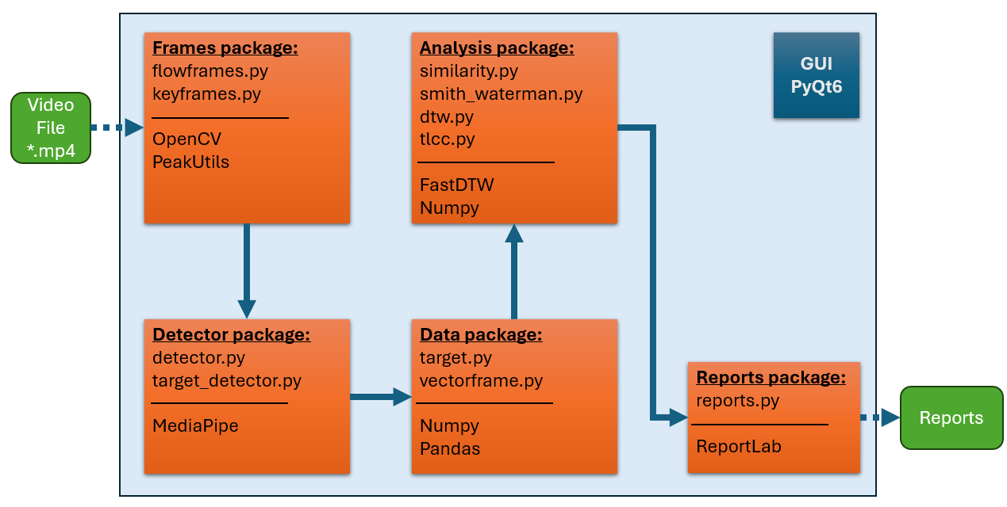

*Architecture overview, with selected main parts of the packages and the libraries used*

### 2.1.7 Challenges

During the development process of the project we encountered a number of challenges, as was expected. For some, we did find a way to overcome while following our initially outlined plan. Some of them demanded from us to find workarounds, and adapt to the given situation

Video Data:

The whole process is highly dependent on the quality of the video data provided.

* Dynamic backgrounds: We found the analysis process to be less than ideal in cases where the video includes highly dynamic backgrounds, for example a video shot in the park with a background full of moving branches and falling leaves.Overall dynamic backgrounds lead to incorrect KeyFrame detection process, as the algorithm being used for keyframe detection cannot discern between the source of the motion.Lowering the detection threshold helps to decrease false-positive keyframe detection instances, but in the same time reduces the amount of minor movement changes that can be detected circumventing the keyframe detection and ensuring the minor changes in the background will be less of an issue



*Example of a wrongly identified ‘Keyframe’ due to the movement of foliage*

* Video quality: As the analysis is being done on the video provided - the quality of the video is very important. The system works better with better quality videos, where the subjects are clearly visible, no video artifacts are present, and the resolution is high enough. At the same time we found that loading extremely high-resolution videos (4k hd) leads to slow work times and can crash the system altogether. A good starting point is 769 x 432 resolution for 16:9 aspect ratio videos, or similar resolution
* Motion blur: Another issue we encountered was motion blur during fast movements in low-frame-per-second videos. In many videos, especially those involving rapid actions and a sub 15 fps, the subjects’ movements became blurred, making it difficult for the system to track body landmarks accurately. This led to incomplete or inaccurate movement vectors, which compromised the synchrony analysis. Unfortunately, adjusting the video processing parameters had limited impact in mitigating this issue, and we had to accept that motion blur would reduce the accuracy of movement detection in fast-paced scenes

Calculation of Motion Vectors:

* Skipped frames and detection failures: part of the challenge in the calculation is due to frames, where body landmarks were either incorrectly detected or not detected at all. This typically occurred when the subjects’ movements were too fast, or when occlusions blocked key parts of their body from being seen by the camera. When detection failed in certain frames, it led to missing or incorrect vectors, as there was no valid coordinate data to calculate movement between frames. To mitigate this, we attempted to estimate the missing data based on adjacent frames. However, this method introduced its own limitations, as interpolating over too many skipped keyframes resulted in an inaccurate representation of the actual movements. In cases where multiple consecutive keyframes were missing, the system tends to struggle still

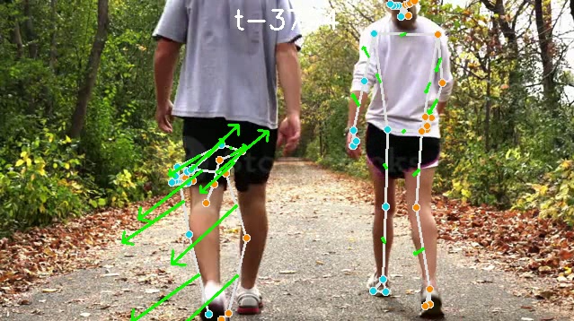

*Example of wrongly identified landmarks on the left target - due to shoulders not being included in the image. We found that having 4 points of the torso in the image - shoulders and hips - greatly helps with the detection*

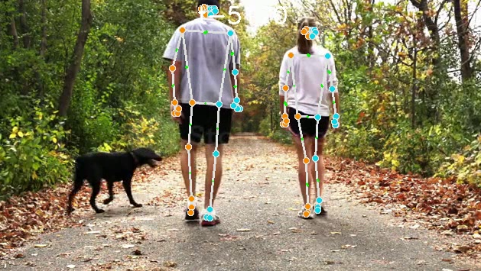

*The issue is solved on later frames - when left target shoulders are in the recording*

* Reliance on the resources of the PC: as the detection is running locally we encountered cases where the increased load on the computer due to other programs running can lead to the sub-par detection and as such - incorrect calculations. While this issue is rare enough, and shows up only during extremely heavy PC loads, we had to adapt and make sure our own code is as optimized as possible under given time constraints
* Coordinate system adjustment: another challenge was the need to adjust the coordinate system used for detecting body landmarks. The MediaPipe library, which we relied on for body detection, outputs landmark positions in normalized coordinates relative to the frame dimensions (i.e., x and y values between 0.0 and 1.0). This coordinates system presents difficulties when comparing movements across different frames or between subjects, especially when the camera angle or distance from the camera varies between subjects. We needed to adapt these normalized coordinates into a more suiting reference system that would allow us to compare movements between subjects more reliably. This required transforming the frame-based normalized coordinates into a flexible coordinate system, centered on each target for it’s motions, that could account for perspective distortions, differences in subject sizes, and other factors
* Identifying and associating targets: in videos with multiple subjects, MediaPipe detects and tracks body landmarks, but it does not distinguish between different targets when detecting. This created a challenge in reliably assigning detected movements to the correct subject over the duration of the video. Without an existing target association mechanism, it was difficult to ensure that the movement vectors corresponded to the intended subject. To address this, we had to develop logic to identify each subject consistently across frames by calculating the center of the target on each movement, by first identifying the shoulders, then selecting the center point between them as a ‘target center’ and lastly looking for proximity match

Synchrony Analysis:

* The goal of our system is the ability to analyse the results gathered. This process relies on algorithms to assess the degree of synchrony between movements. Applying these algorithms to real-world data ended up posing several challenges. We have to admit that during Stage A process we did not dive deep enough into the analysis process and focused mainly on the data extraction, and in the end had to dedicate a non-insignificant amount of development time into adapting these algorithms to our data.
* Basic similarity analysis: while the most straight-forward of all, this process can be highly resource intensive with the run time being O(N^2). We had to use parallel processing to make this analysis viable on larger datasets, and it still takes time, as there is not a lot of optimization that can be done to a one-on-one comparison of each movement of one subject with all the movements of the second subject
* DTW: This algorithm is a known and a valuable tool for aligning sequences of data, even when time series vary in speed or timing. However, one of the primary challenges we encountered with DTW was its computational complexity, which lead to us using an adapted FastDTW algorithm instead, which is while almost as precise much less computationally-intensive. Additionally, we found that DTW does work best to align similar sequences and great when the subjects are explicitly trying to move in synchrony. When the subjects are moving freely it fails to align rare similar movements in the overall data we gather
* TLCC: Same as with DTW -this algorithm does work best when the subjects are trying to move in synchrony. When the subjects are moving freely it fails to align - which is to be expected. One possible workaround we implemented is to try and align movement on each axis separately, giving more insight into the movement, and a better chance of finding similarity and lag if present

Reporting:

* Data organization: one of the challenges was organizing the data produced by the system's different analysis methods into a cohesive and user-friendly report format. Each algorithm generates different types of data, such as distance measures, alignment scores, or correlation coefficients, all of which need to be structured logically. Making sure that the output of these different methods could be clearly presented without overwhelming the user was a major hurdle
* Presenting data: our system generates a significant amount of numerical data during the analysis phase, including similarity scores, distances, correlations, and alignment costs. Presenting these raw numbers in a way that is easy to interpret posed a challenge. To address this, we are presenting the data together with a clear explanations and, where possible, thresholds for interpreting the results
* Data visualization: this was one of the more complex aspects of the report generation process. The system produces several types of visualizations, them being time-series plots and alignment graphs, all of which ,we hope, provide insights into the synchrony between subjects. However, ensuring that these visualizations were both accurate and easy to interpret required few iterations of graph ideas

## 2.2 Testing Process

### Validation Testing

For the validation testing we went onwards with a collection of videos gathered from the Stock Videos sites online. We looked for videos that had following characteristics:

* Two detection targets
* Motion present
* Resolution of 768 x 432 or better

Additionally, we recorded some videos with ourselves as targets and used them as part of the general video data for the analysis.

We tried to cover as big set of conditions as possible, with some of the conditions found to be problematic for the detection process, which allowed us to come to a general ‘preferred video rules’ that should guide the user to the best possible outcome.

After we went through a detection process, we manually compared the videos with the detection results to verify the correctness of the detection methods.

We do feel like there is additional value to be found in a more diligent verification process, preferably being done as part of a larger study, containing multiple measurement methods, and being performed by team that includes people specializing in the Interpersonal Synchrony research.

As an example of two people walking in sync, we expect to see the similarity in the motions of the feet, walking. It also can be observed that the hands are mirrored – while the person on the left of the image has the cup in the right hand – the person on the right of an image has the cup in the left hand:

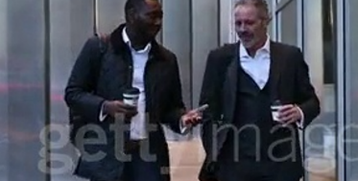

*A cut and a zoom of the video, showing cup positions*

Frames from the video showing the movement progression:

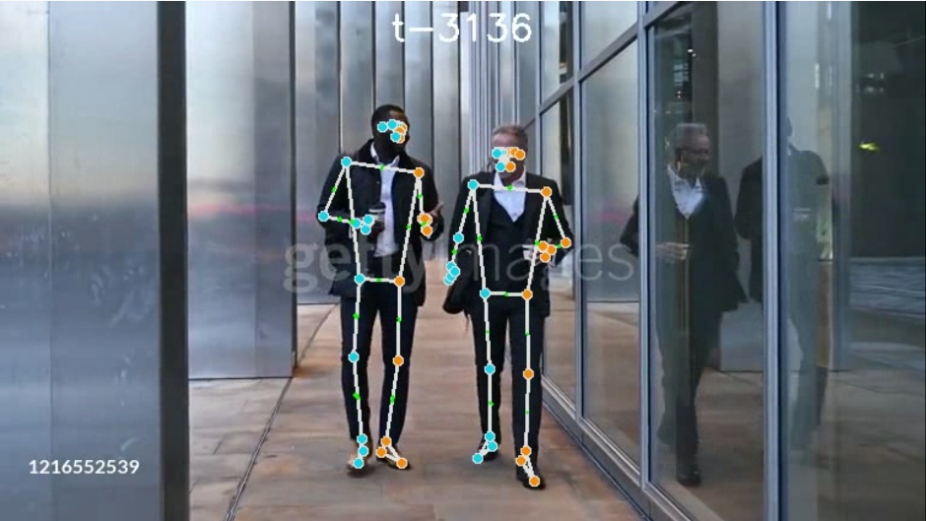

Frame at t=3136ms

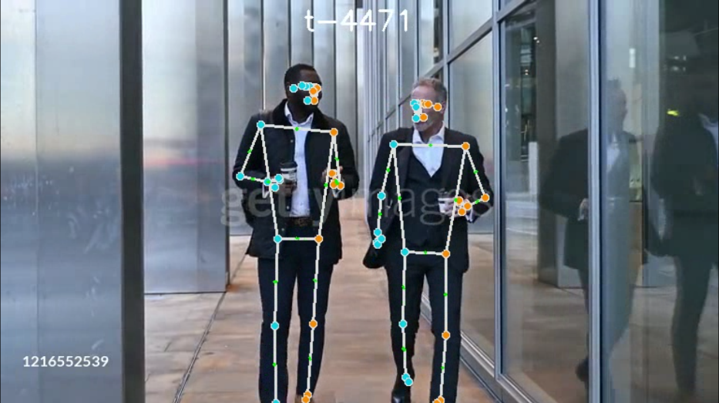

Frame at t=4471 ms

Accordingly, when checking results of the DTW analysis we can observe an allignment, with DTW distance of 1.2 for lower left leg, and 1.6 for lower right leg which can be counted as a good alignment -

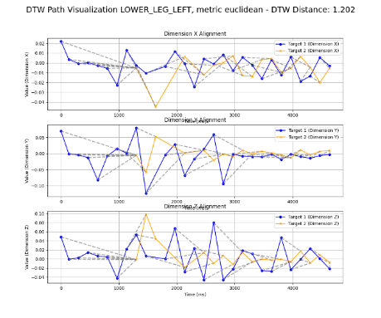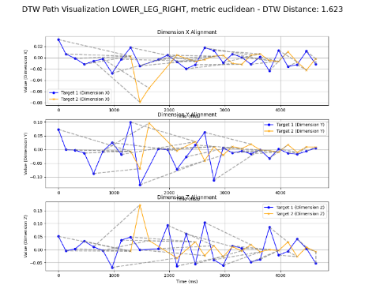

Same with the Smith-Waterman analysis:   
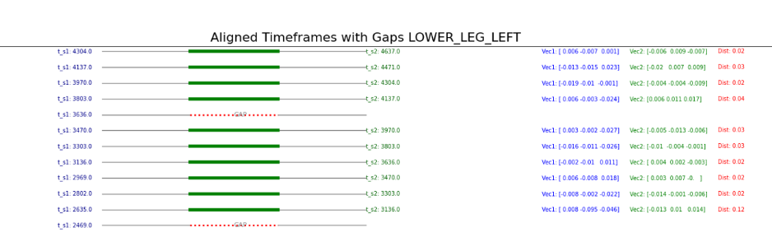

We can see good alignment for legs, especially during the 2000 to 4500ms, as per the illustrations above

Comparing to sparse alignments of, for example, right arm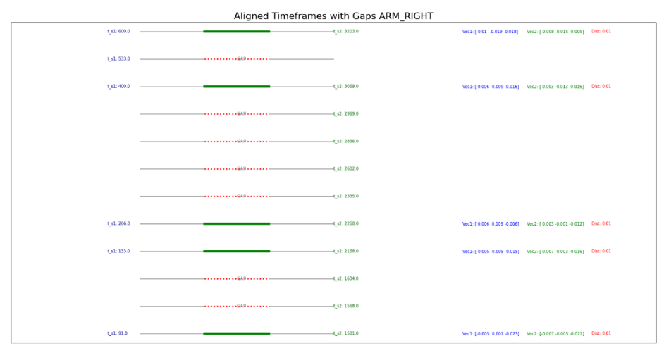

The video segment discussed above is 4 seconds long, with 2 seconds of perfect detection.

Next example is a video of 17 seconds, which depicts people acting in full synchrony, and as such we can see a very different image:

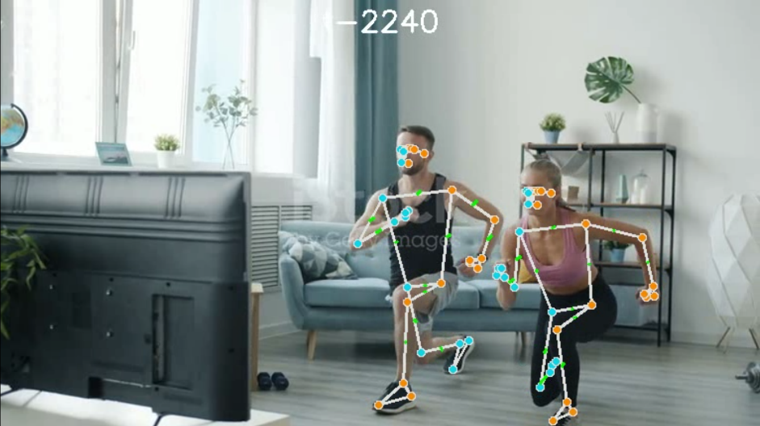

*Detection results at t=2240ms*

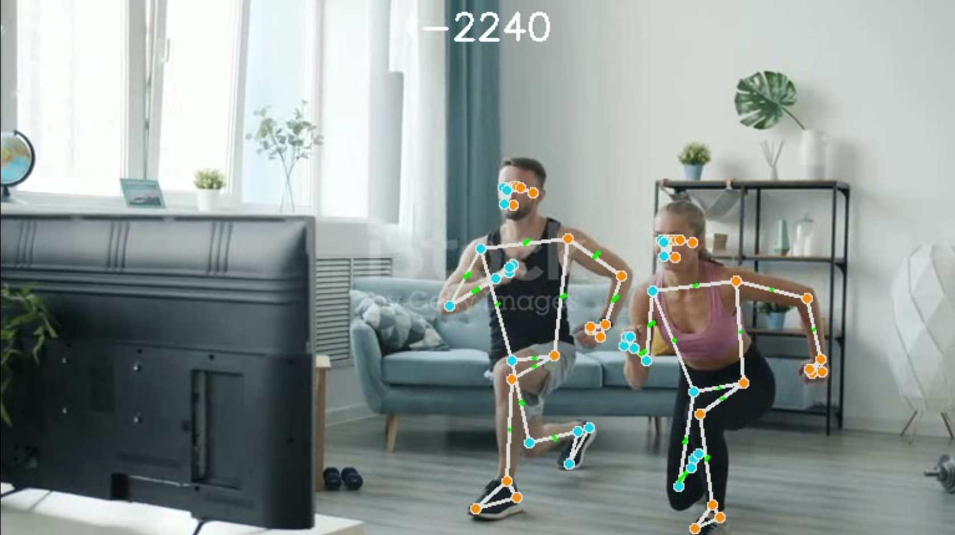

*Cropped and zoomed in from previous illustration - The detection of obscured / overlapping body parts – in this example the right legs for both subjects are not clearly visible, but still detected correctly*

In this example we can see how a good alignment looks for a long video:

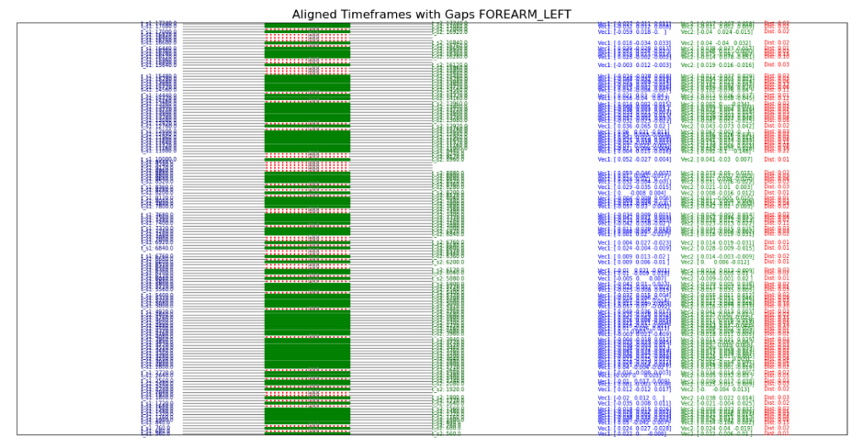

Smith-Waterman Alignment for left forearm

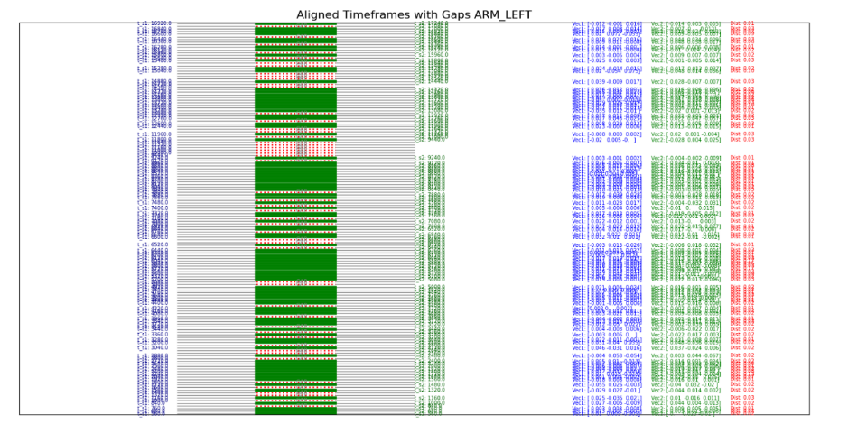

Smith-Waterman Alignment for left arm

Example of an issue with the detection and it’s effect on detection result:

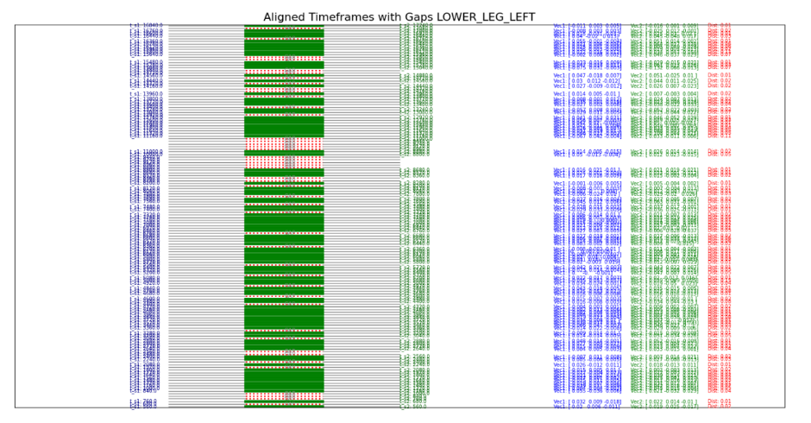

Notice the gap at around 8800 t2 for the left leg synchrony measurement

With the detection error skewing the data:

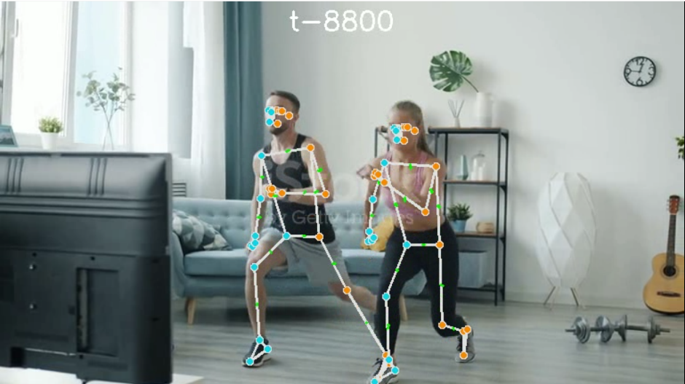

Example for detection issue due to the model incorrectly predicting the leg location due to another subject’s leg located near

Same issue is visible on the DTW analysis plot for lower left leg synchrony:

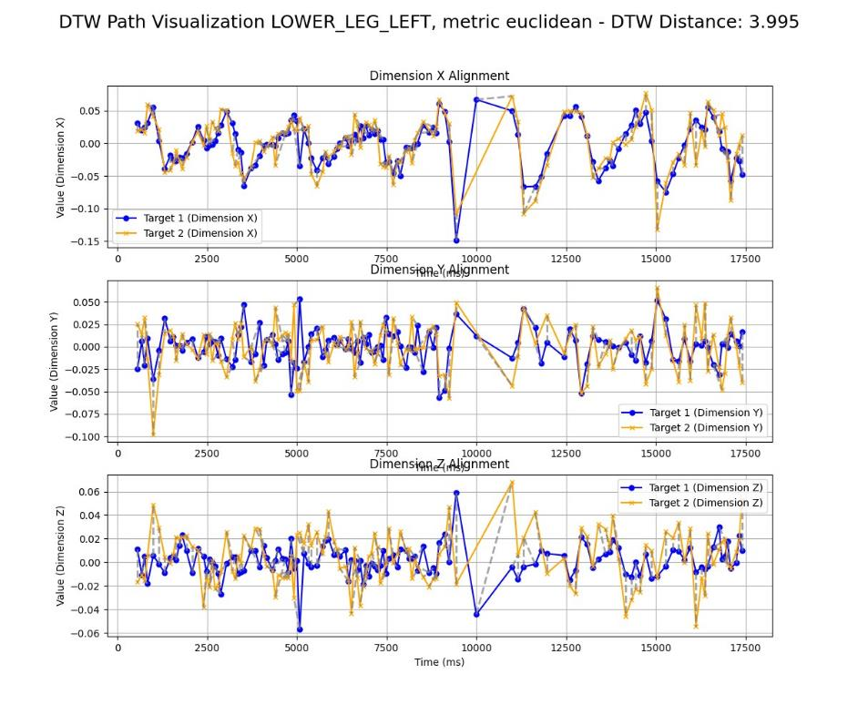

### Detection Issues and Challenges

Examples from videos analysed where the detection did not work properly, with the reasons marked by us – this section should be used as an example of what videos would be not fitted for our project in its current state. An update for the detection model by MediaPipe in the future might improve our ability to analyze some of these videos.

Full Occlusion:

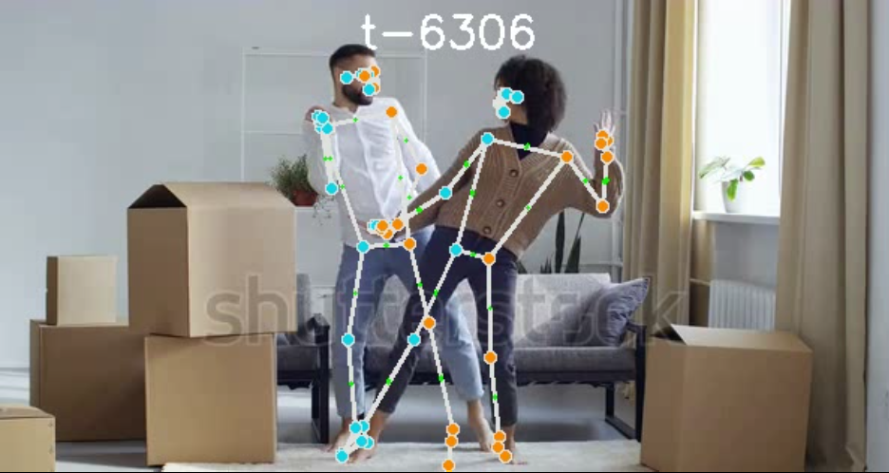

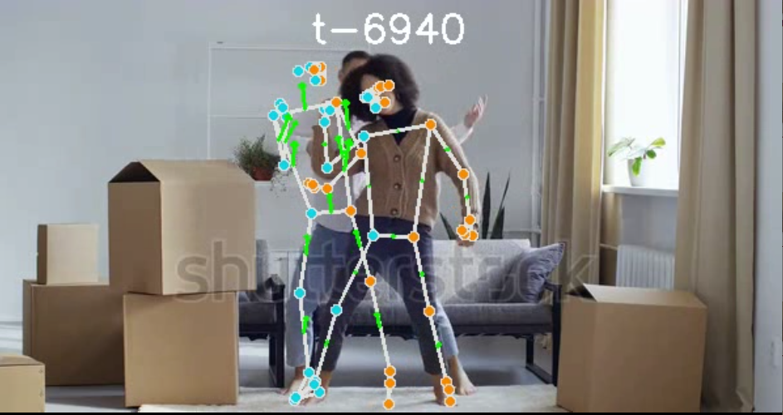

In this video we can see the subject in the back being lost during the full transition behind the subject in front. Unlike partial occlusion – full occlusion is still an issue that should be solved going forward

Unorthodox positions:

Currently model has issues with detecting subjects in highly unorthodox positions:

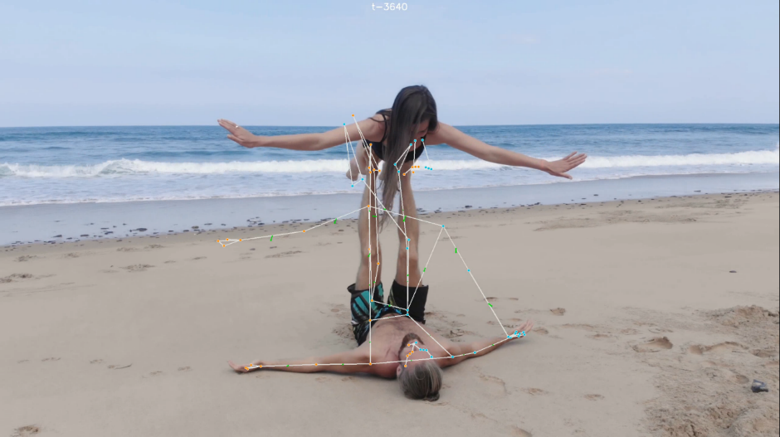

In this example none of the targets was identified correctly

Clothing that hides the figure:

Some types of clothing, under certain conditions can lead to issues with detection. Next video is an example – notice the subject on image right got an open coat moving freely around

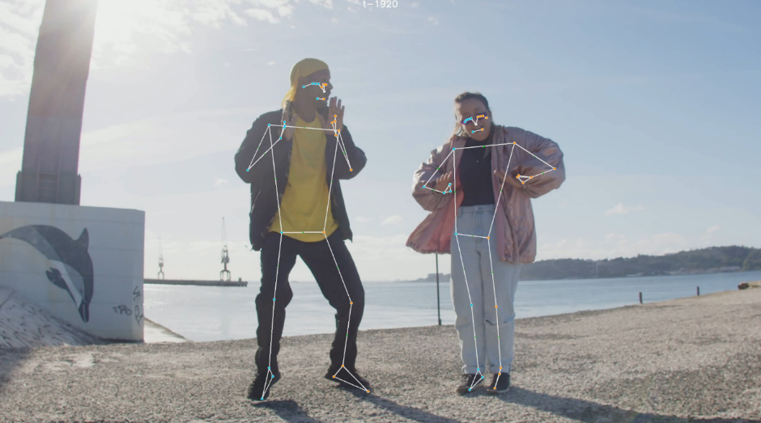

On some frames this is not an issue and the detection works correctly

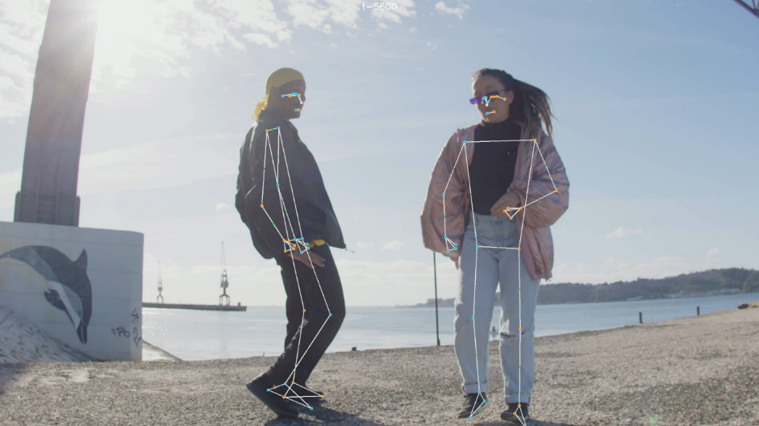

Another highly successful detection for the same video, including the extrapolation of the locations of the hidden limbs on the left target

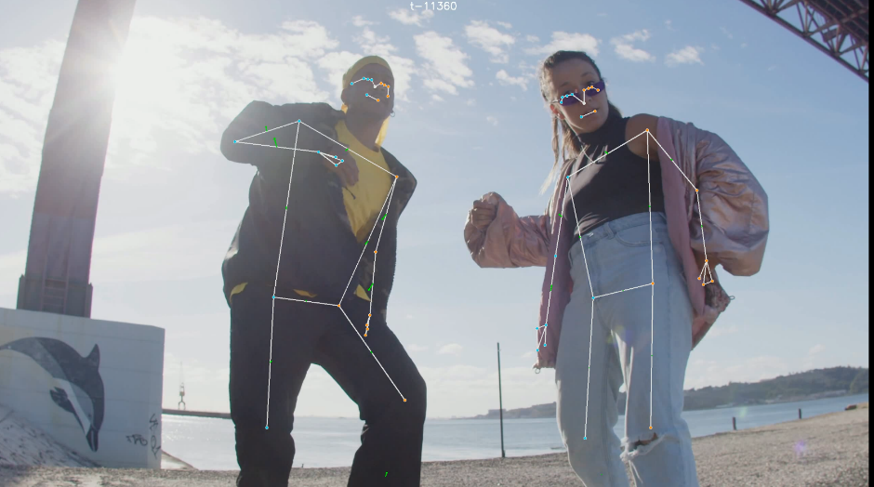

And then the coat is being detected as a hand, while the hand is missing.

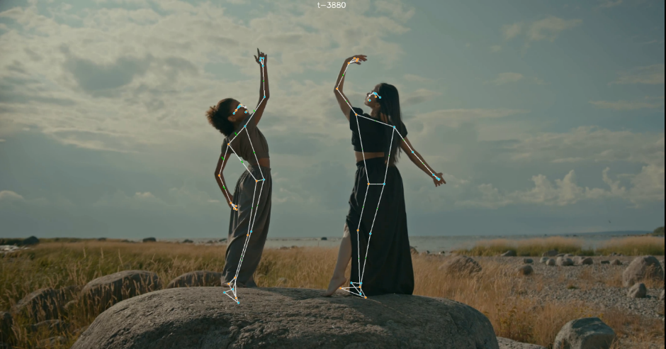

Another example of clothing interfering with the detection process, from a different video. The detection process tries to estimate unsuccessfully the location of the subjects legs due to the oversized clothing.

Bodies not fully visible

We advice to have 4 points visible in the image for each target for best detection result – 2 shoulders and 2 hips.

In the extreme overlap situations the system will try and detect leading to uncertain results:

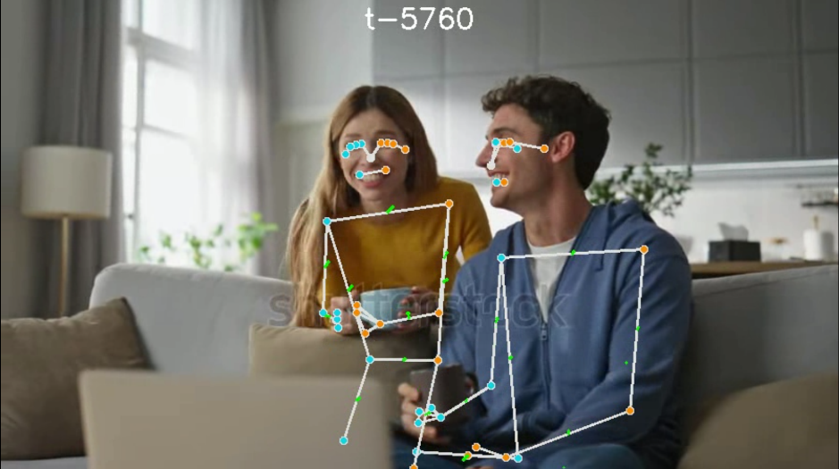

In another example of not-fully-visible subjects we can actually receive a decent enough result of detection:

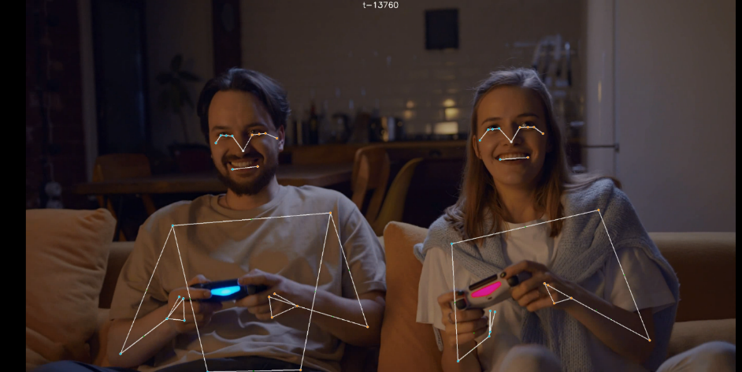

The system detects the parts visible correctly. In a case like this it is on the user to overview the video and decide what parts should be analysed, and if the analysis should be trusted

### Functional Testing

The testing process was performed with accordance with the testing plan outlined during Stage A of the project and was performed manually, as follows:

|  |  |  |
| --- | --- | --- |
| **Use Case** | **Test** | **Confirmed Test Result** |
| **User Opens the Program** | Test GUI Initialization | The program GUI initializes and loads correctly without errors. |
| **Upload Video Recording** | Test Open File Dialog | The "Open File" dialog appears when initiated by the code. |
|  | Test File Opening and Loading | The selected video file loads correctly into the program |
|  | Test Video Handling | The program can handle various video sizes and lengths without errors. |
|  | Test Video Preview | The video preview displays correctly. |
|  | Test Menu Bar Initialization | Menu bar items such as File, Reports, and Settings load correctly. |
|  | Test Video Playback Controls | Video playback controls (play, pause) function correctly. |
| **Set Video Analysis Settings** | Test Default Settings | Default settings are applied if no custom settings are specified. |
|  | Test Default Time Codes | Defaults to 00:00 for start and video end for end if not specified. |
|  | Test Time Code Setting for Estimation Start | Start time code is limited by end time code |
|  | Test Time Code Setting for Estimation End | End time code is limited by start time code |
|  | Test Input parameters for analysis | System displays appropriate error messages for Invalid Input parameters |
| **Perform Pose Estimation** | Test Keyframe Extraction in Single Motion Single Person Video | Keyframes are extracted correctly according to frame difference for a single motion, single person video |
|  | Test Keyframe Extraction in Multiple Motions Single Person Video | Keyframes are extracted correctly according to frame difference for multiple motions, single person video |
|  | Test Keyframe Extraction in Single Motion Multiple Persons Video | Keyframes are extracted correctly according to frame difference for a single motion, multiple persons video |
|  | Test Keyframe Extraction in Multiple Motions Multiple Persons Video | Keyframes are extracted correctly according to frame difference for multiple motions, multiple persons video |
|  | Test Pose Landmark Detection for a Single Person Video | The system identifies and accurately tracks pose landmarks for a given frame using the MediaPipe library. |
|  | Test Pose Landmark Detection for a Multiple Persons Video | The system identifies and accurately tracks pose landmarks for a given frame using the MediaPipe library. |
|  | Test Keyframe Data Recording | The system correctly records the actor and time code for each keyframe. |
|  | Test Keyframe Vector Extraction | Vectors are extracted and calculated correctly where motions start/stop and points appear/disappear. |
|  | Test Pose Estimation Performance and Speed | Pose estimation completes efficiently without significant delays. |
|  | Test Pose Estimation with two Actors | The system identifies and tracks two actors without errors. |
| **Analyze Interpersonal Synchrony** | Test Movement Vector Calculation | Movement vectors for each body part of every participant are correctly calculated. |
|  | Test Synchrony Analysis Using DTW | IS analysis using DTW method works as expected. |
|  | Test Synchrony Analysis Using Movement Vectors Similarity Analysis | IS analysis using Movement Vectors Similarity Analysis method works as expected. |
|  | Test Synchrony Analysis Using Smith Waterman | IS analysis using Smith Waterman method works as expected. |
|  | Test Synchrony Analysis Using TLCC | IS analysis using TLCC method works as expected. |
|  | Test Analysis Failure Handling | System displays appropriate error messages for failed analyses (e.g., no persons detected). |
|  | Test Analysis Success Handling | System displays a success message for successful analyses. |
| **Generate Report** | Test Report Generation | The system generates a report summarizing analysis results. |
|  | Test Report Customization | Generated reports are customizable based on user preferences. |
|  | Test Report Formats | Reports are available in both PDF and CSV formats. |
| **Saved Reports** | Test Report Path | Reports are saved to a predefined path |
| **User Interaction Flow** | Test Button Enabling/Disabling | System unblocks buttons at appropriate steps (e.g., 'Perform Synchrony Analysis'). |
|  | Test Terminal Logger | The system manages a terminal that provides feedback messages throughout the process. |
|  | Test Settings Customization | The system operates according to predefined settings that can be customized based on user preferences. |

## 2.3. Conclusions

Our InterSync project successfully developed a robust system for detecting and analyzing Interpersonal Synchrony (IS) using advanced computer vision techniques. Leveraging MediaPipe for body landmark detection and applying various algorithms, such as Dynamic Time Warping (DTW), Time-Lagged Cross-Correlation (TLCC), and an adapted version of the Smith-Waterman algorithm, we aimed to create a system capable of assisting researchers in analyzing movement synchrony between subjects

Key achievements

One of the key successes of our project as we see it is in the creation of a system that can measure synchronization not just across entire bodies but at a more granular level—focusing on specific body parts. Traditional tools like Motion Energy Analysis (MEA) fall short in this respect, as they lack the capability to isolate and analyze the movements of individual limbs or other body segments in a full body recording. By offering this detailed, part-specific synchrony measurement, our system enables deeper insights into how different parts of the body move in synchrony with another subject, enhancing the understanding of movement patterns

The system also successfully incorporates multiple algorithms for synchronization analysis. Each algorithm—whether DTW for global sequence alignment, TLCCfor time-lag correlation, or Smith-Waterman for detecting localized synchrony—offers its own advantages, giving researchers flexibility based on the type of data they are working with. For example, DTW is ideal for analyzing interactions where timing between movements varies, while Smith-Waterman pinpoints brief but significant moments of synchronization within longer interactions

Limitations

Several limitations became evident during the project. The system's accuracy is heavily reliant on the quality of the video data. Poor-quality video with low resolution, noise, or rapid motion led to difficulties in body landmark detection, which in turn affected the accuracy of the movement vectors. This problem was particularly prominent in more challenging environments, where external conditions such as lighting or background motion could confuse the detection algorithms

Another limitation comes from the computational demands of some of the algorithms, While the implementation of FastDTW helped reduce the processing time, working with large datasets or high-frame-rate videos still poses a challenge

Additional limitation is the MediaPipe model we are using for detection – as mentioned before – one of the parameters for the project was to assure it would work on a medium-spec laptop pc, which in turn limits the detection model. MediaPipe library is optimized for mobile devices, and as such might be sometimes lacking in its detecting ability.

Impact

Despite challenges outlined, our system offers a significant step in automatic synchrony analysis. The ability to generate comprehensive reports in multiple formats (PDF, Excel, CSV) will hopefully make it easier for researchers to quickly review the results of the analysis. These reports provide both detailed numerical data and visual representations of the synchrony between subjects, saving researchers time and effort in analyzing the data manually

## 2.4. Future work and improvements

While we feel that currently the application is good enough to stand on its own as a possible tool for Interpersonal Synchrony analysis, there is always a possibility for improvement. We listed few of the areas where we feel there is a place for such improvement to be done:

Improved video data handling

* Dynamic background filtering: possibly incorporating methods to differentiate between background noise and subject motion in complex environments. Future iterations could include techniques like background subtraction that could help mitigate the effects of moving objects in a scene
* Noise reduction: adding more robust filtering to handle low-quality videos with artifacts or compression issues could enhance the accuracy of movement vector calculations

Enhanced computational efficiency

* Parallel processing: implementing parallel computation techniques to allow for analysis of large datasets could improve efficiency and usability of our project
* Algorithm optimization: further optimization of the existing algorithms, such as Smith-Waterman and TLCC, could reduce the computational needs, particularly when analyzing long sequences or large-scale interactions.

Real-Time synchrony analysis

* Capability to handle real-time video analysis: currently, the system is designed for post-hoc analysis of pre-recorded videos, but real-time analysis would open up a range of new use cases, such as live monitoring of social interactions in clinical or educational settings
* Real-Time data processing: optimizing the pipeline to handle frame extraction, landmark detection, and synchrony calculation in real-time
* Immediate feedback: user interface update to add the ability to display synchrony metrics and visualizations in real-time as the video is being recorded / analysed

Improved target tracking

* Automatic tracking: additional computer vision and calculation-based techniques to better assign landmarks to specific subjects in multi-subject videos. Could be done using methods such as facial recognition or object tracking
* Improvements to handling occlusions: implementing strategies for better handling of occlusions or cases where subjects move in and out of the frame, ensuring that landmark tracking and movement analysis remain consistent

Expansion of synchrony metrics

* Custom synchrony metrics: allow users to define custom scoring rules for what constitutes synchrony based on their particular use case
* Additional algorithms: integrating more advanced machine learning models or other alignment algorithms could enhance the system’s flexibility and precision in detecting synchrony

Usability enhancement:

* Interactive reports: interactive report formats that allow users to explore synchrony data dynamically, such as adjusting time frames or thresholds directly within the report
* Updated visualizations: including more intuitive graphs and better guidance on interpreting the results

# **3. User Documentation**

## 3.1 User Documentation

### Table of Contents:

1. Introduction
2. System Requirements
3. Installation
4. Application Interface Overview
5. Key Features
   * Opening Video Files
   * Video Analysis
   * Synchrony Analysis
   * Generating Reports
6. Settings
7. Dark and Light Mode
8. Logging and Terminal Messages

### 1. Introduction

The InterSync Application is a desktop tool designed for video analysis and interpersonal synchrony analysis. It allows users to load videos, analyze pose landmarks, perform advanced synchrony analysis using various metrics, and generate customizable reports.

### 2. System Requirements

* Operating System: Windows, macOS, or Linux
* Python 3.12 - This is important - some of the libraries used will not work otherwise
* Required Libraries, with the versions included. (can be copied into requirements.txt)
  + fastdtw==0.3.4
  + joblib==1.4.2
  + matplotlib==3.9.2
  + mediapipe==0.10.14
  + numpy==2.1.1
  + opencv_contrib_python==4.10.0.84
  + openpyxl==3.1.5
  + pandas==2.2.2
  + PeakUtils==1.3.5
  + PyQt6==6.7.1
  + PyQt6_sip==13.8.0
  + reportlab==4.2.2
  + scipy==1.14.1
  + seaborn==0.13.2

### 3. Installation

* Install Python 3.x: Make sure Python 3.x is installed on your system and available in PATH. This step is mandatory and cannot be automated. Use either <https://www.python.org/downloads/> or Windows App Store
* Download the project code, using one of the following options:
  + Download from <https://github.com/Dana-Bet/InterSync.git>
  + Let the Git do the work by using command *git clone*
* Run the script ‘start.bat’ in the root of the project. The script will do the following:
  + - 1. Create Python virtual environment (venv) – on the first run only
      2. Download all the required libraries – on the first run only
      3. Run the GUI

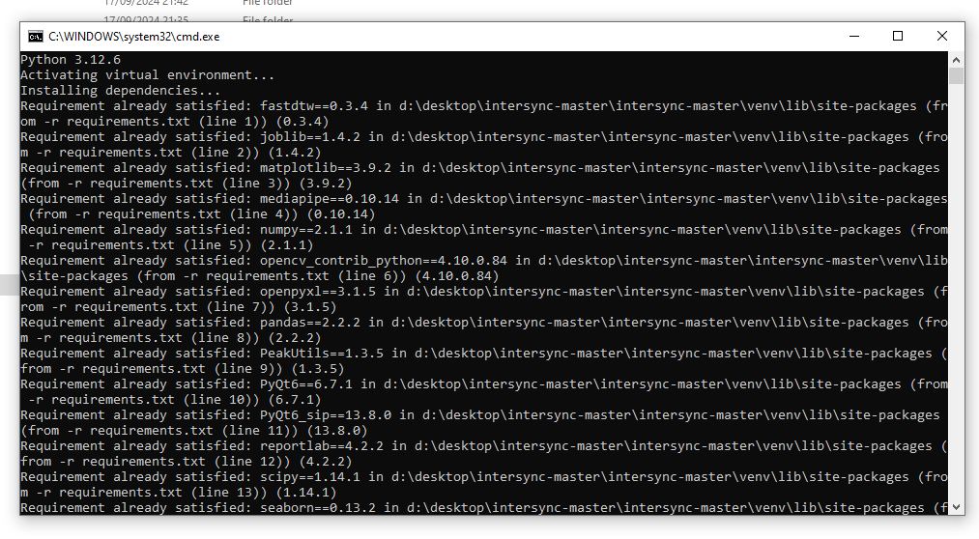

*Example of ‘start.bat’ running. No need to worry – it should look like that!*

### 4. Application Interface Overview

The InterSync Application’s main window is structured into the following components:

**Menu Bar (Top):**

* Located at the top of the window, the menu bar includes:
  + **File:** Contains options for opening video files.
  + **Reports**: Options related to generating and viewing reports.
  + **Settings:** Access to the settings menu to customize the application preferences (e.g., dark mode, export directory).

**Vertical Sidebar (Left):**

* Three main buttons are aligned vertically:
  + **Video Analysis:** Opens the video analysis window to configure and run video analysis on the loaded video file.
  + **Synchrony Analysis:** Access the synchrony analysis window once video analysis is complete.
  + **Generate Report:** Allows users to generate reports summarizing the analysis results.

**Tab Widget (Center - Right):**

* **Original Video Tab:** Displays the original video that the user loads for analysis. Once the video is loaded, it appears in the video player widget within this tab.
* The tab layout allows for easy switching between the Original Video and additional analysis results tabs (to be populated after video and synchrony analysis).

**Video Player:**

* The video player is located in the main tab labeled Original Video and includes:
  + A playback bar that shows the current time of the video.
  + Play, pause, and time display controls located directly below the video display area.

**Message Terminal (Optional - Not shown):**

* Located below the video player in some views, this area logs messages and notifications about the application’s actions and events.

### Key Features

Opening Video Files

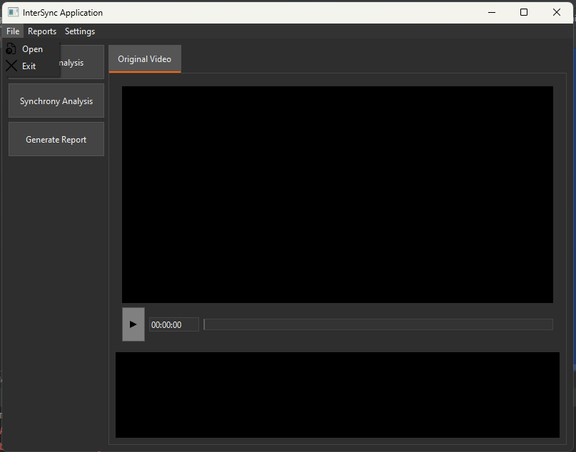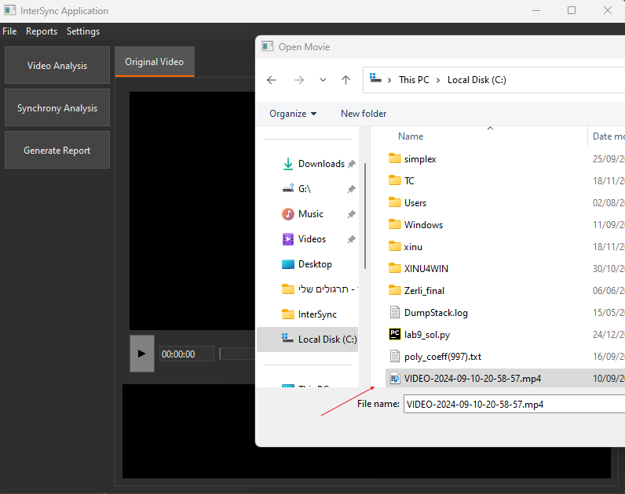

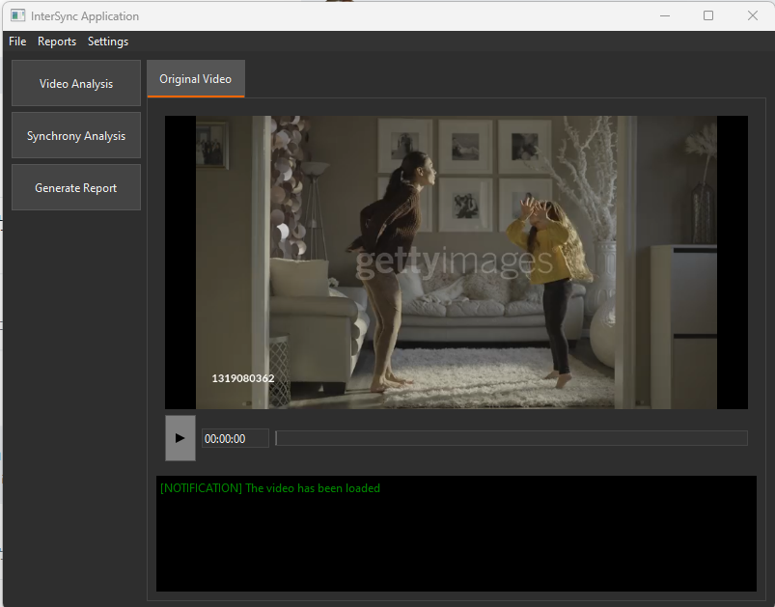

1. **Open File**:
   * Click on the "File" menu and select **Open** to load a video file.
   * The video file is displayed in the player on the first tab titled "Original Video".
2. **Supported File Formats**:
   * Supports common video formats such as .mp4, .avi, and .mov.

#### Video Analysis

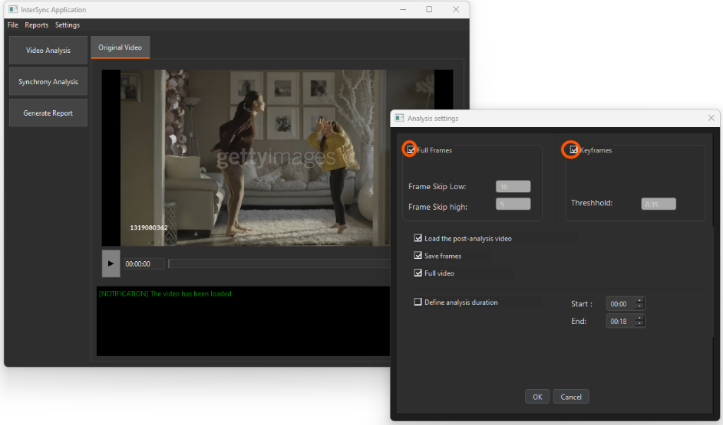

*User is given an option to choose either Keyframe detection methods, where the system tried to intelligently decide where the motions start and stop, or to choose Full frame option where the video is split into consecutive frames, and every n’th is chosen for the future analysis.*

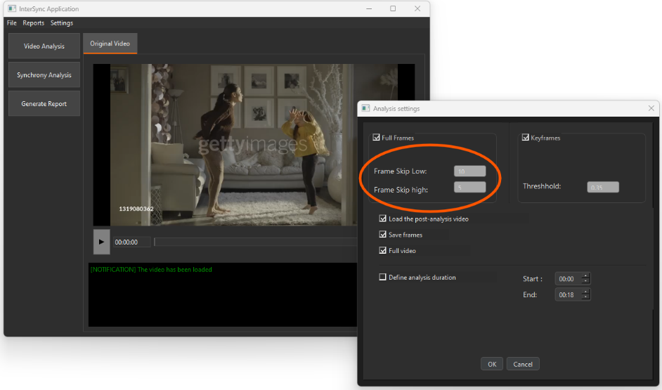

*The system evaluates the number of frames per sec in the loaded video.  
If the video defined to be a “high-frame” one (there are more than 30 frames per second) – the system will analyse every ‘Frame skip high’ frame, in the example provideded – every 5th frame.  
If the video defined to be a “low-frame” one the system will analyse every ‘Frame skip low’ frame, in the example provideded – every 10th frame.*

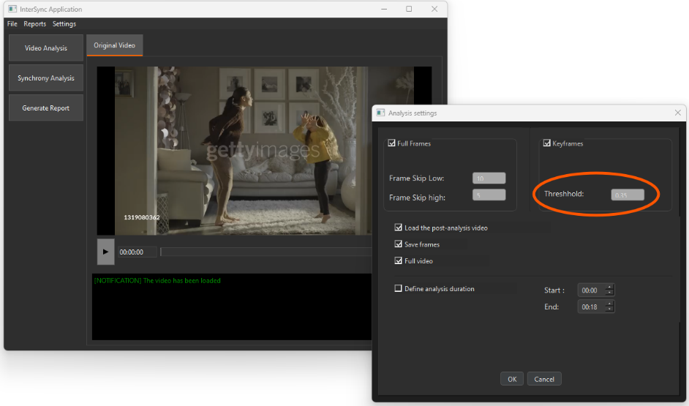

Choosing the keyframe method necessitates defining a threshold. The threshold parameter determines the level of similarity between frames.

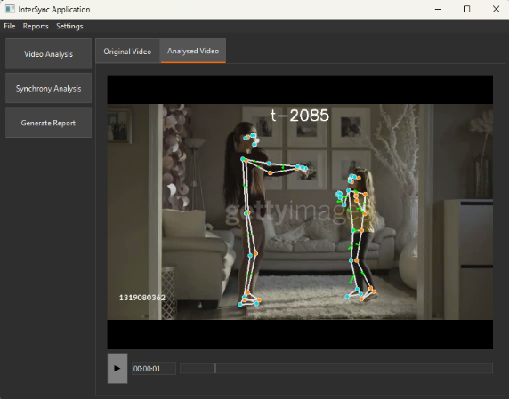

Checking the 'Load the post analysis video' option will make the analysis video, which includes landmarks and vector direction movements (in green), available for viewing in the application main window.

1. **Start Video Analysis**:
   * Click on **Video Analysis** to open the video analysis window.
   * Set the time range or analyze the entire video.
   * Choose between full-frame analysis and keyframe extraction based on thresholds.
   * You can also specify whether to save frames and generate plots during analysis.
2. **Options**:
   * **Frame Skipping**: You can specify the number of frames to skip during the analysis.
   * **Keyframe Extraction**: Provide a threshold to determine significant key frames based on motion differences.

#### Synchrony Analysis

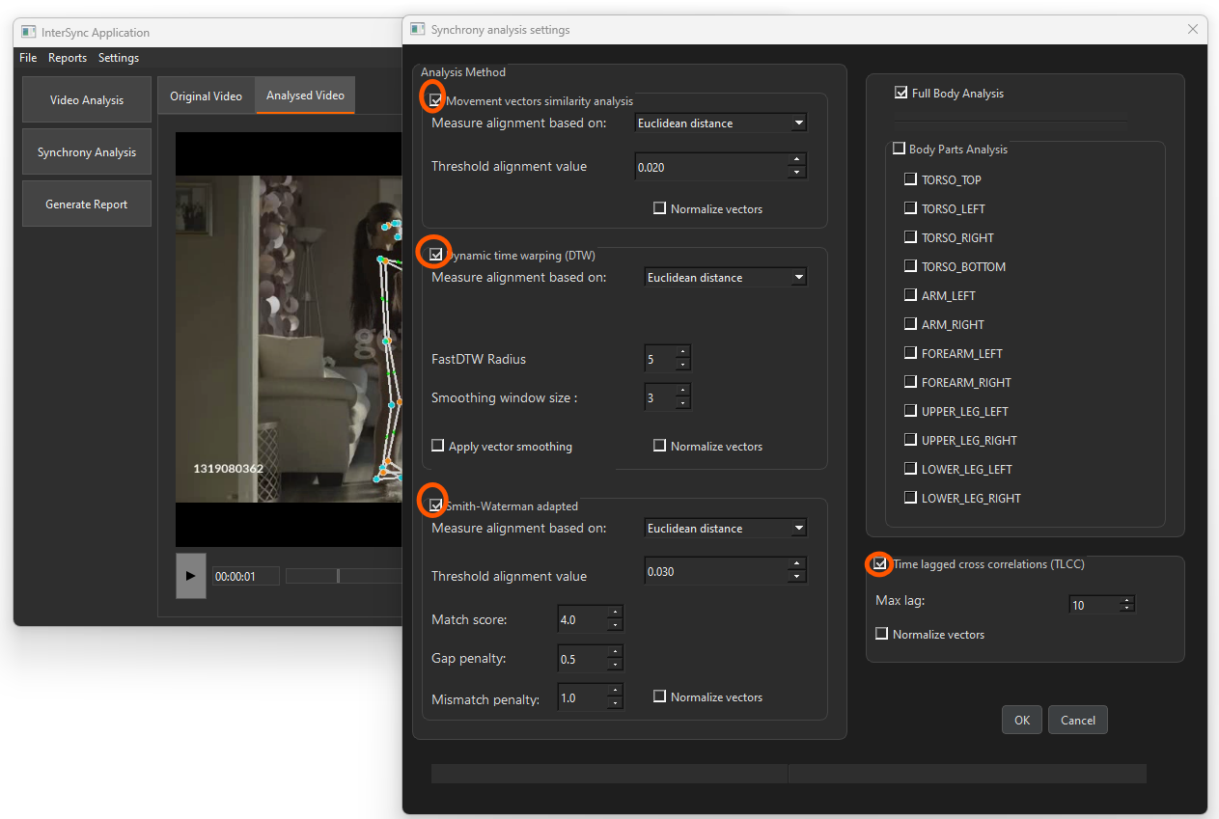

*After the video analysis is finished successfully, the Synchrony Analysis window will be enabled.  
Four analysis techniques can be utilized: TLCC, DTW, Movement vectors similarity analysis, and Smith-Waterman adapted. At least one should be selected*

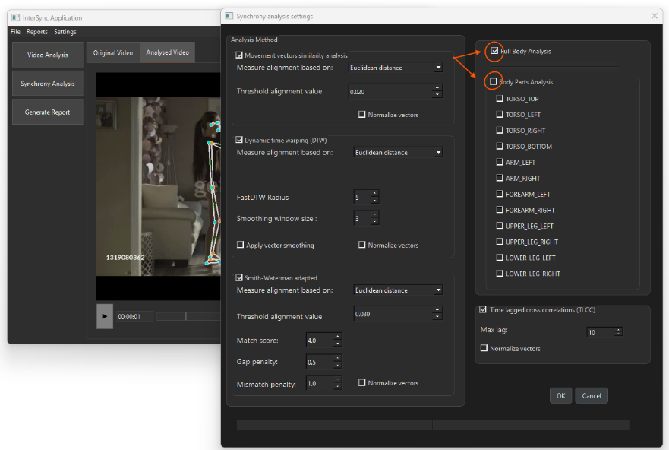

*The user should choose between ‘Full Body Analysis’ to ‘Body Parts Analysis’*

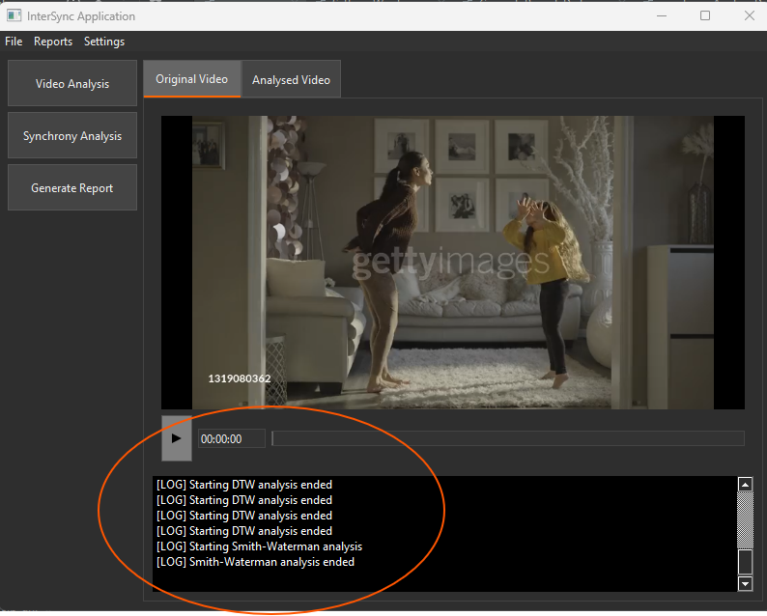

Terminal including notification and monitoring about analysis progress

1. **Open Synchrony Analysis**:
   * After performing video analysis, click on **Synchrony Analysis**.
   * Select body parts (e.g., arms, legs, torso) for analysis or choose full-body analysis.
   * Various metrics are available, including **Euclidean Distance**, **Cosine Similarity**, and **Dynamic Time Warping (DTW)**.
2. **Metrics and Methods**:
   * **DTW** (Dynamic Time Warping): Aligns movement trajectories for comparison.
   * **Smith-Waterman Algorithm**: Used for local sequence alignment of movements.
   * **RWTLCC (Time-Lagged Cross-Correlation)**: Synchrony detection over time-lagged windows.
   * **Movement Vectors Similarity Analysis**

#### Generating Reports

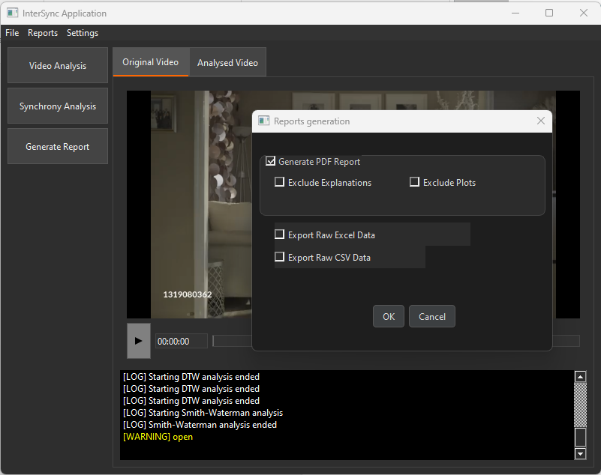

1. **Open Report Generation**:
   * Click on **Generate Report** to generate a summary of the analysis.
   * Reports can be customized based on user preferences and saved in different formats such as PDF or CSV.
   * View and download reports within the application.
2. **Report Contents**:
   * Summary of key frames, pose landmarks, and synchrony analysis.
   * Comparison metrics based on body parts or full-body movements.
3. **Accessing the Reports:**
   * Reports can be found in the folder defined in ‘Settings’, by default – the project root, in the subfolder marked by the Analysis Run timestamp i.e. ‘2024-12-31-23-59-59’

#### Settings

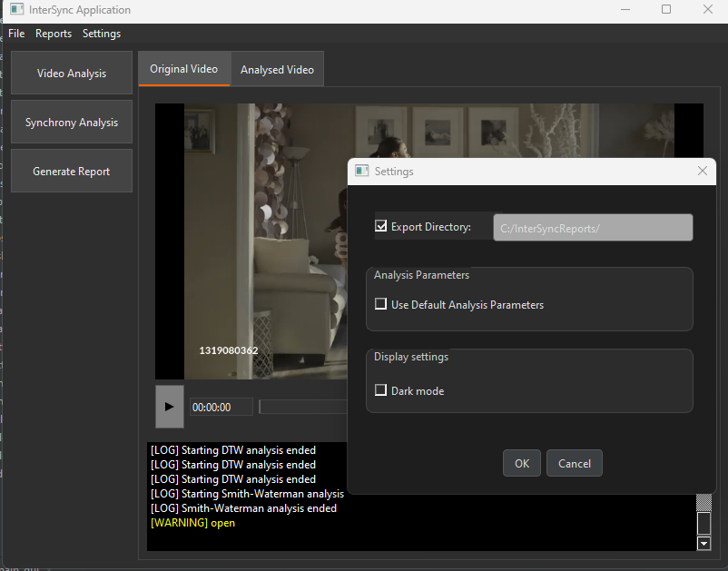

*Application settings window*

1. **Open Settings**:
   * Access the settings via the "Settings" menu.
   * Customize parameters such as:
     + **Export Directory**: Set the path where all analysis and reports are saved.
     + **Default Parameters**: Define default settings for analysis (e.g., thresholds, metrics).
2. **Dark Mode**:
   * Toggle between dark and light themes in the settings.
   * The changes will immediately apply to the interface.

#### Dark and Light Mode

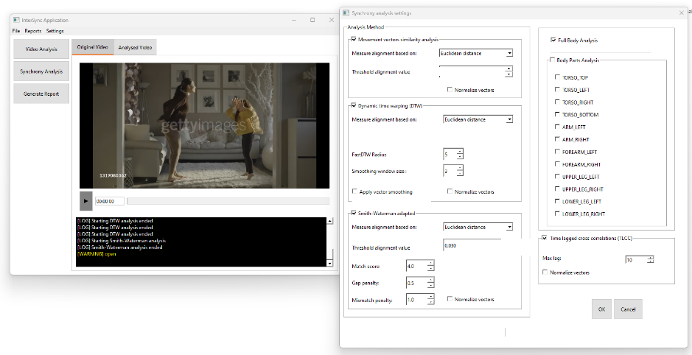

Synchrony Analysis Window in Light mode

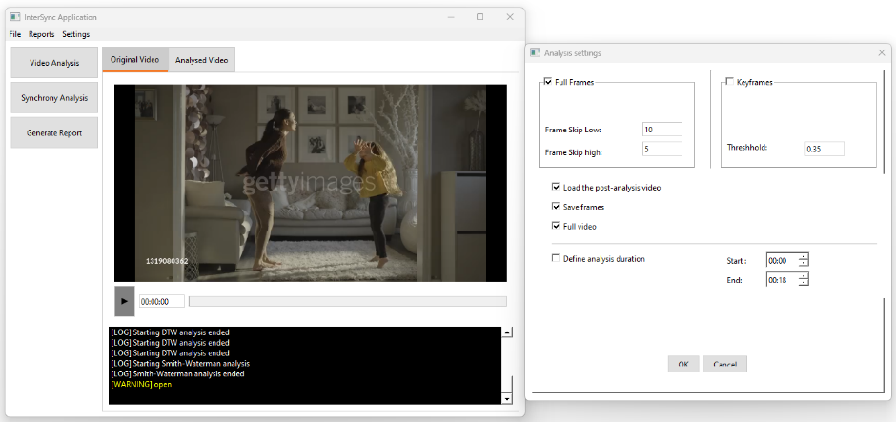

Video Analysis Window in Light mode

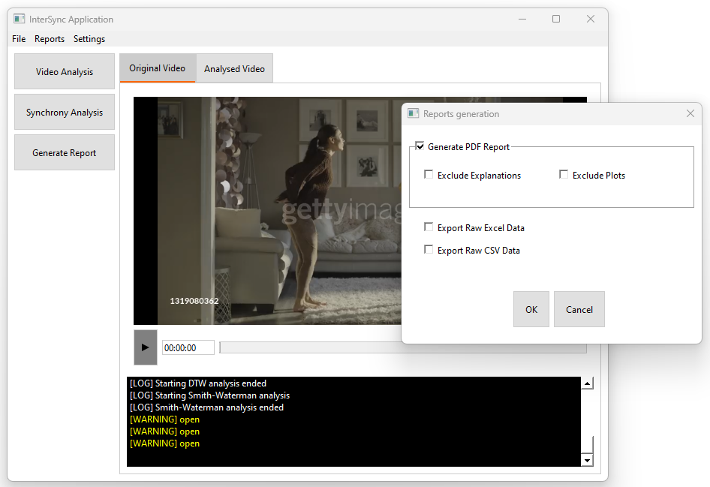

Generate Repots Window in Light mode

The application supports both dark and light modes for user interface customization.   
You can toggle between these themes in the settings window:

* **Dark Mode**: Best for low-light environments.
* **Light Mode**: Suitable for well-lit environments.

To switch themes:

1. Open the settings window.
2. Enable or disable dark mode using the checkbox.
3. Click "OK" to apply the changes.

## 3.2 Maintenance guide

Libraries and Frameworks:

* Keep main libraries - MediaPipe, OpenCV, NumPy, and Pandas updated to the latest stable releases when possible
* Regularly check for updates to FastDTW, PeakUtils, and ReportLab to ensure compatibility and performance improvements

GUI and Front-End components:

* Update PyQt6 as needed to maintain compatibility with operating systems and ensure security patches are applied

Performance tuning:

* Review the algorithms (DTW, TLCC, Smith-Waterman) for performance optimization, and use updated analysis values, especially in cases of large videos that can produce large data sets

Bug fixes:

* Advised to maintain a tracking system for algorithm-specific bugs, ensuring that errors in synchronization, movement detection, or mismatches are logged for possible future code updates

Data management:

* Use data storage strategies for archiving video recordings and analysis results (CSV, Excel, PDF). Use cloud storage or network drives for large datasets.
* Regularly remove outdated or unnecessary video files and data exports to manage storage space efficiently.
* Establish backup plan, ensuring that all critical project data and analysis reports are securely backed up to prevent loss